Research Questions:

Are females more likely to have had an HPV vaccine than males?
How do rates of HPV vaccination differ by gender and age?

libname mydata "/courses/d59155e5ba27fe300" access=readonly;

/*calling in NHIS data set*/
data new; set mydata.NHIS2013QUBES;

/*sorting data household, family and individual*/;
proc sort; by hhx fmx fpx;

/*ASKING FOR OUTPUT (GRAPH, TABLE, LIST, ANALYSIS, ETC) GOES HERE*/
proc means; var age_p; run;
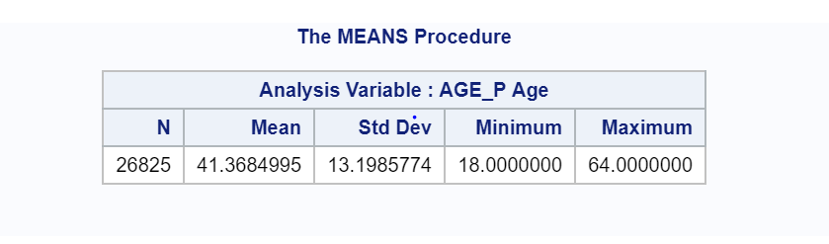
proc freq; tables shthpv2 sex; run;
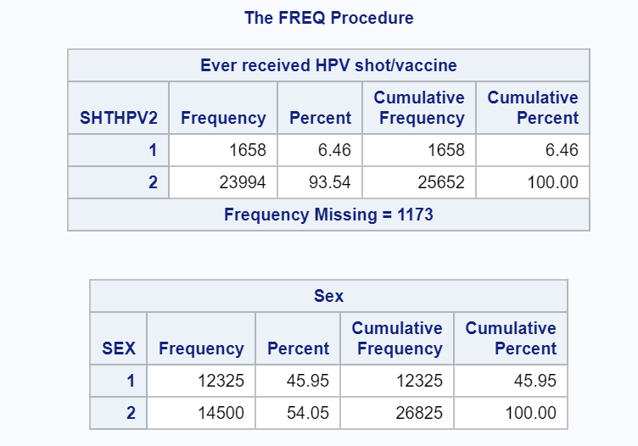
proc freq; tables shthpv2*sex; run;
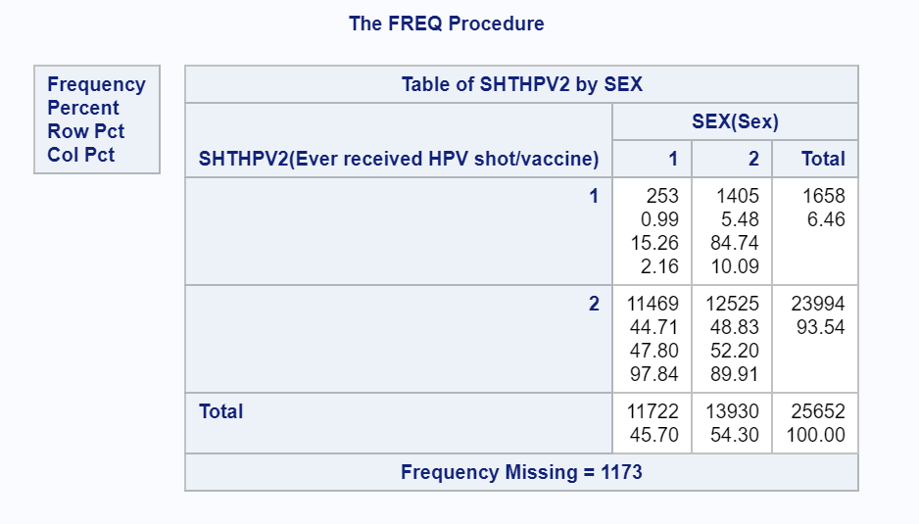

proc sort; by agegroup;
proc freq; tables shthpv2*sex; by agegroup; run;

