The Green Revolution of the late 1950s marked the advancement of agriculture technology and the development of high-yield crops became a priority in agriculture. In tropical Asia, the Green Revolution helped farmers to solve the problem of the brown planthopper (BPH), an insect pest that devastates rice crops. Prior to the Green Revolution the population density of the brown planthopper was naturally regulated by a variety of native predators, including spiders and insects. Although the development of rice cultivars and GMOS, synthetic fertilizers, and synthetic pesticides advertised increased production, farmers are facing larger problems than ever before. In fact, the end result was that an initial strategy to increase rice yields and avert crop failure has had the exact opposite effect.

Developing improved rice cultivars with insect and disease resistance is an important objective of rice breeding, as these are the major threats to productivity. The variation in rice genetics has led researchers to identify individual rice plants with natural traits of resistance, which were then used to breed with other rice plants to create the cultivars with improved resistance. Following the Green Revolution as technology was advancing, development of high-yield crops also became a priority. Beginning in the 1960s, the production of rice in tropical Asia evolved from a low-yield traditional system developed by farmers and produced with few artificial inputs to a high-yield scheme founded on genetically improved cultivars.

The first high-yield cultivar was introduced in 1966 and increased rice production dramatically in some areas. The new rice cultivars reached harvest maturity relatively quickly compared to the traditional cultivars, which meant that farmers with irrigation systems could harvest two and sometimes three crops from the same rice paddy in a single year. Monocultures of the new high-yielding cultivars appeared year round in many irrigated areas. However, the continuous succession of monocultures over large areas provided abundant BPH habitat that enabled the populations to reproduce nearly year round. As technology continued to advance, cultivars that were both high-yielding and also pest-resistant were developed.

It quickly became a new priority to expand development of cultivars with genetic resistance to BPH, and the first high-yielding strain with BPH resistance was released in 1974 (Figure 1). It was successful for less than three years because the rapidly reproducing BPH could themselves adapt to overcome this resistance within 7-10 generations. There is some hope though: it has also been shown that non-improved rice cultivars planted in mixtures with genetically resistant varieties have been shown to have much greater yields than when planted alone.
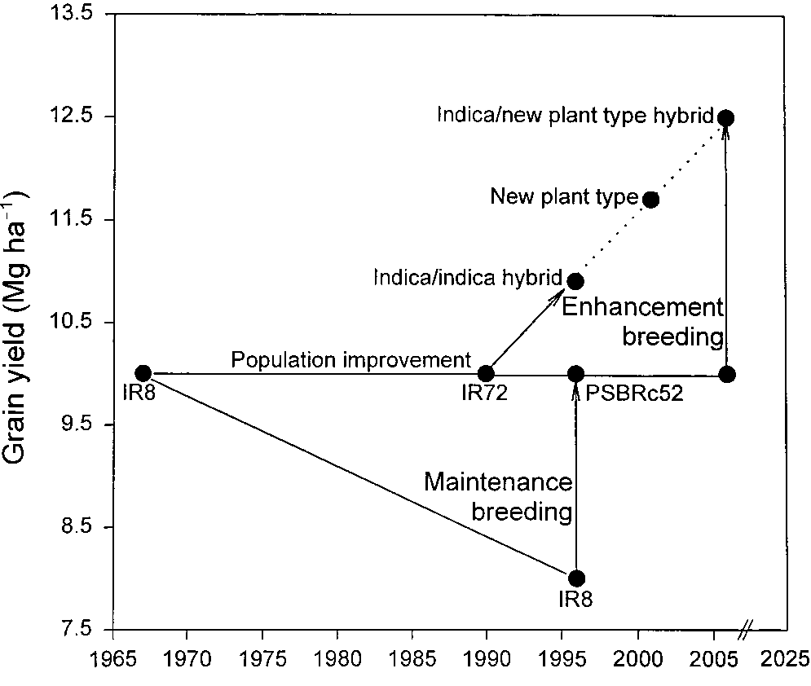

Figure 1: The figure to the left shows the history of the performance of various rice cultivars. Arrows represent development of new cultivars; each solid dot is a new or enhanced cultivar.

Discussion Questions

- What positive and negative outcomes result from rice cultivar development?

- Why would mixing plantings of different cultivars slow the development of pest resistance?

- What likely happened with strain IR8 between 1966 and 1996? Consider both the figure and the information from the article.

- Identify any words, topics, acronyms, etc. that you did not know or understand from the introduction. In addition, use the space below to write one question that relates to the information presented.

References
Bottrell, D.G., K.G. Schoenly. (2012). Resurrecting the Ghost of Green Revolutions Past: The Brown Planthopper as a Recurring Threat to High-Yielding Rice Production in Tropical Asia. Journal of Asia Pacific Entomology, 15, 122-140. **Most of this activity is excerpts from this paper.
Heinrichs, E. (1992). Rice insects: The Role of Host Plant Resistance in Integrated Management Systems. Korean Journal of Applied Entomology, 31(3), 256-275.

