Antibody Binding

Introduction
Antibodies are proteins that react with foreign invaders during a humoral immune response. Antigens, small substituents of foreign invaders, elicit an immune response when they bind to the antibody. Variable regions of amino acid chains comprising the antibody create binding sites. A particular antibody has specificity to bind to one or more particular antigens.

Importance
Quantitatively we can describe the binding of antigens to antibodies. Experimentally, this allows us to gather information about properties of the antibody and the specificity of antibodies to particular antigens.

Questions
How is antigen binding to an antibody related to antigen concentration? How can we determine binding properties of antibodies?

Variables
b | number of bound antigens (moles)
a | total number of antibodies (moles)
c | total concentration of antigen (mols/liter)
n | number of binding sites on antibody
K | equillibrium constant of the antibody (liters/mol)

Methods
During an immune response, the number of antibodies bound to a particular antigen depends on the concentration of that antigen as well as the number of binding sites on the antibody. Each antibody has a limited number of binding sites that become saturated as the concentration of antigen increases. This can be quantified by the following equation:
$$\frac{b}{a}=\frac{K_{cn}}{1+K_{c}}$$ | LaTeX Code: \[ \frac{b}{a} = \frac{K_{cn}}{1 + K_c} \]
where b/a gives the proportion of bound antigens per antibody, c is the antigen concentration in the surrounding solution, and K, the equilibrium constant of the antibody, relates the speed with which the antibodies become saturated. We can plot b/a as a function of c.
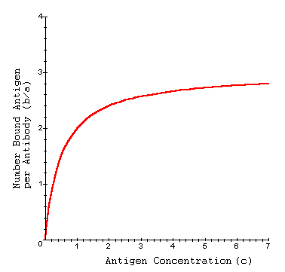
Generally, K and n are unknown for a particular antibody. Scatchard developed the following useful equation to describe the antigen binding by algebraically rearranging the previous equation:
$$\frac{b}{ac}=K\left(n-\frac{b}{a}\right)$$ | LaTeX Code: \[ \frac{b}{ac} = K \Bigg( n - \frac{b}{a} \Bigg) \]
where b/ac is the number of bound antigens per antibody for a particular antigen concentration c, n is the number of binding sites on the antibody, K is the equilibrium constant of the antibody.
Experimentally, one can place antibodies in a solution of antigens and measure properties of the system at equilibrium. The system reaches equilibrium when as many antigens as possible have bound to the antibodies. At equilibrium, we can know b, a, and c, and can plot b/ac as a linear function of b/a according to the Scatchard equation. This allows us to estimate K and n for the antibody.
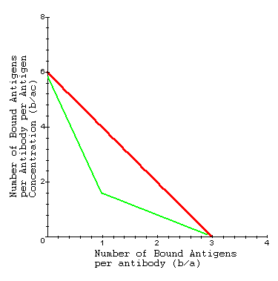

Interpretation
Using the Scatchard equation, we can then estimate the equilibrium binding constant (K) as the slope of this line (red line). A steeper slope implies the binding of antigens to antibodies reaches equilibrium more quickly (i.e. at a lower concentration or higher value of b/ac). As the antigen concentration goes to infinity, we attain equilibrium. Therefore, we can also estimate the number of binding sites (n) as the x-intercept (set b/ac = 0 and solve for b/a).
Experimentally, antibodies can be surrounded by a solution containing different types of antigens. When the experimental data is plotted, we do not get a straight line (green line). In this case, we can assume the antibody has specific binding sites for more than one type of antigen.

Conclusion
The binding of antigens to antibodies can be described quantitatively as a function of antigen concentration. By rearranging this equation, we can experimentally gather information about properties of the antibody.

Additional Questions
1. Choose different values for K. How does this affect the plot of b/a as a function of c?
2. Look again at the first equation for b/a. What is b/a as the antigen concentration (c) goes to infinity?
3. Look at the line b/ac. What is the x-intercept?

Source
Darnell, J., H. Lodish, and D. Baltimore. 1986. Molecular Cell Biology. Scientific American Books, Inc., New York
Goueli, S. A. and R. C. Steer. 1981. Some representative mathematical plots in biological research. From Advanced Cell Biology, L. M. Schwartz and M. M. Azar, eds. Litton Education Publishing, Inc., New York

About this Resource
This material was originally distributed as part of “Alternative Routes to Quantitative Literacy for the Life Sciences” - National Science Foundation Award DUE-9752339 to the University of Tennessee, Knoxville for August 1, 1998 - July 31, 2000. Principal Investigator: Louis J. Gross. Co-Principal Investigators: Beth C. Mullin and Susan E. Riechert.
This material is now being revised as part of the “Resources for Improving Quantitative Skills in Community College Biology” project. As part of that project is also aligned with the OpenStax Biology Textbook.
It is published using the QUBES Open Education Resources publishing platform.

http://www.tiem.utk.edu/~gross/bioed/
https://qubeshub.org/community/groups/quantbioatcc/
https://openstax.org/details/books/biology-2e
https://qubeshub.org/qubesresources/publications/1040/

