Chemoreception

Introduction
Chemoreception occurs when specific receptors in the cell membrane bind with diffusing chemicals in the surrounding medium. For example, bacteria such as E. coli and Salmonella often navigate in response to chemical attractants or repellants.

Importance
A cell that depends on chemoreception must devote a certain amount of its resources and surface area to building receptors. Building a large number of receptors throughout the cell membrane certainly increases the cell's ability to detect a chemical, but it is also costly to the cell. We can use simple equations and graphs to examine how a cell can have adequate chemoreception without high cost.

Questions
Should a cell invest a large amount of resources and surface area in building chemoreceptors in its cell membrane in order to detect chemicals?

Variables
P | probability of a molecule finding a receptor
N | number of receptors in cell membrane
s | radius of receptor (micrometers)
r | radius of spherical cell (micrometers)

Methods
For a spherical cell of radius r, the probability (P) that a molecule that has collided with the cell will find a receptor can be expressed as
$$P=\frac{Ns}{Ns+rπ}$$ | LaTeX Code: \[ P = \frac{Ns}{Ns + r \pi} \]
where N is the number of receptors in the cell membrane and s is the radius of each binding site. As the number of sites (N) gets very large, 100% of the molecules are likely to collide with a receptor.
We will compare the probability of chemoreception with the amount of cell surface area devoted to receptors. The surface area of a spherical cell is given by 4πr² and the area of a binding receptor is given by πs². The proportion of the cell's surface area covered by receptors can be estimated as N(πs²)/4πr².
By graphing these two equations we can gain a lot of information. Assume a receptor radius of 10 angstroms (1 micrometer = 10⁸ angstroms) and a cell radius of 10 micrometers.
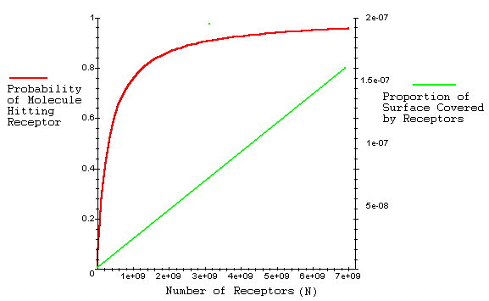
The probability of a molecule colliding with a receptor, graphed as a function of N, increases rapidly at first and then asymptotically approaches a probability of 1.0 as N gets very large. The proportion of the cell's surface area covered by receptors increases linearly.

Interpretation
Certainly, for very large N, the cell is well covered by chemoreceptors, and almost 100% of diffusing molecules are likely to bind. However, a small number of receptors, taking up considerably less area, have a probability almost as high due to the quickly increasing nature of this function. Because of the asymptotic nature, above a certain number of receptors, the probability of binding only increases slightly by having additional receptors. Yet the cell gain s the additional burdens of building chemoreceptors and losing surface area.

Conclusion
One expects a cell to have optimum performance (a high probability of chemodetection without a high cost) when only a small fraction of the cell surface has chemoreceptors. A cell can devote only a minor amount of resources to building receptors, but still be able to detect chemicals in its surroundings.

Additional Questions
1. Look at the probability (P) equation again. Formally calculate the horizontal asymptote. What happens as N goes to infinity?
2. How would our analysis change if a cell could only have a limited number of receptors (N is fixed), but could vary their size (s)?

Source
Berg, H. C. and E. M. Purcell. 1977. Physics of chemoreception. Biophysical Journal 20:193-219

About this Resource
This material was originally distributed as part of “Alternative Routes to Quantitative Literacy for the Life Sciences” - National Science Foundation Award DUE-9752339 to the University of Tennessee, Knoxville for August 1, 1998 - July 31, 2000. Principal Investigator: Louis J. Gross. Co-Principal Investigators: Beth C. Mullin and Susan E. Riechert.
This material is now being revised as part of the “Resources for Improving Quantitative Skills in Community College Biology” project. As part of that project is also aligned with the OpenStax Biology Textbook.
It is published using the QUBES Open Education Resources publishing platform.

http://www.tiem.utk.edu/~gross/bioed/
https://qubeshub.org/community/groups/quantbioatcc/
https://openstax.org/details/books/biology-2e
https://qubeshub.org/qubesresources/publications/1041/

