Lung Capacity and Rhythms in Breathing

Introduction
The respiratory system functions to filter, warm, and humidify the air we breathe, and to supply cells with oxygen while removing carbon dioxide. In animals that breathe with lungs, air moves into the lungs through the trachea and then back out again. When each breath is completed, the lung still contains a volume of air, called the residual volume. Each inhalation adds additional air. Each exhalation removes approximately the same volume as was inhaled.

Importance
Normal breathing involves rhythmic inhaling and exhaling. Therefore, we can quantify breathing using trigonometric equations. Changes in breathing, such as those due to increased activity, can then be measured.

Questions
How does lung capacity change over time? How does activity affect lung capacity?

Variables
y | property exhibiting a rhythm (lung capacity)
t | time
A | amplitude
p | period
s_{y} | phase shift in height of y

Methods
An apparatus called a spirometer is used to measure the volume of air inhaled and exhaled while breathing. A spirogram is the record of the changing volumes over time. The output of a spirogram can be quantified using trigonometric equations.
In general, we can describe any repeating rhythm by a sine wave:
$$y=\left(\frac{A}{2}\right)\sin\left(\frac{2π}{p}\left(t\right)\right)+s_{y}$$ | LaTeX Code: \[ y = \Bigg( \frac{A}{2} \Bigg) \sin{\Bigg( \frac{2\pi}{p}(t) \Bigg)} + s_y \]
where y is some property that exhibits a rhythm, t is time, A is the amplitude, p is the period, and s_{y} is a phase shift in the height of y compared to the simplest sine wave (y = sin t where s_{y}=0). s_{y} can be thought of as the value of y half way between the peak and crest of the wave. The amplitude of a wave is the height from peak to crest. For the simplest sine wave, y = sin t, the amplitude is 2. The period of a wave is the time for completion of one cycle. For y = sin t, the period is 2π.
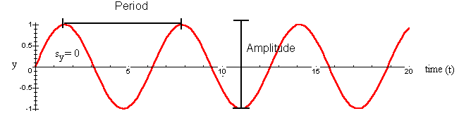
In humans, when each breath is completed, the lung still contains a volume of air, called the functional residual capacity (approximately 2200 mL in humans). Each inhalation adds from 500 mL of additional air for normal (resting) breathing. Each exhalation removes approximately the same volume as was inhaled. The volume of air inhaled and exhaled normally is called the tidal volume. It takes approximately 5 seconds to complete a single cycle. With this information, we can develop an equation for lung capacity as a function of time for normal (resting) breathing. Since s_{y} describes the midpoint of the sine wave, we take the functional residual capacity plus 1/2 the amplitude to give us s_{y}=2200+250=2450 mL. Our period is the time for a single cycle, or p=5 seconds. The volume of air inhaled gives the amplitude, or A=1000 mL. We therefore have the following equation for normal breathing:
$$lung capacity=\left(\frac{500}{2}\right)\sin\left(\frac{2π}{5}\left(t\right)\right)+2450$$ | LaTeX Code: \[ lung\ capacity = \Bigg( \frac{500}{2} \Bigg) \sin{\Bigg( \frac{2\pi}{5}(t) \Bigg)} + 2450 \]
which we can graph.
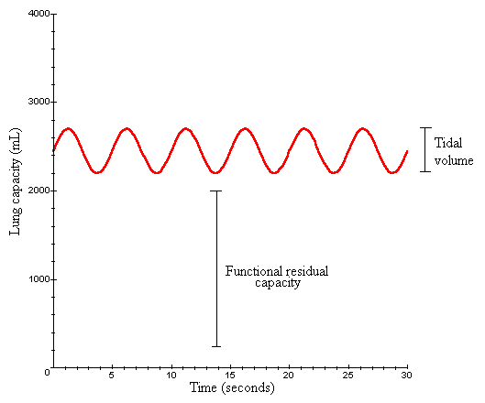
As the degree of activity increases, the volume inhaled and exhaled increases from 500 up to 3000 and the functional residual volume decreases as greater amounts of air are exhaled. In our equation for lung capacity, this is reflected as an increase in amplitude (A) and a decrease in functional residual capacity.
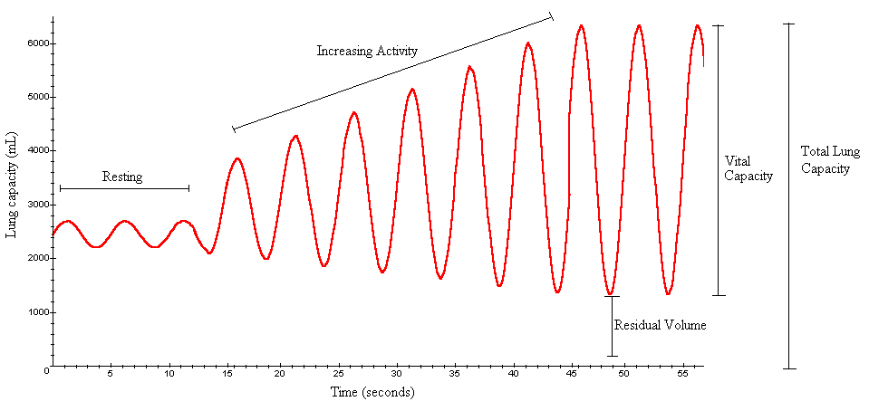

Interpretation
As activity increases, a greater amount of air is forced in and out of the lungs. As a result, the reserve volume in the lungs decreases. However, the lungs have a limited total capacity of 5700-6200 mL. When inhalation and exhalation are at their maximum, the vital lung capacity is reached (approximately 4500-5000 mL). There is a residual volume remaining in the lungs (approximately 1200 mL), even with maximum exhalation, that cannot be forcibly expired.

Conclusion
We can use trigonometric equations to quantify changes in lung capacity over time. Quantifying lung capacity in the form of spirograms is useful for diagnosing illnesses or respiratory problems. Also, patterns in breathing are likely to differ among different groups of people and under differing circumstances.

Additional Questions
1. Determine an equation for lung capacity as a function of time when breathing is forced at maximum and minimum exhalation. Assume the vital capacity is 4000 in order to determine amplitude. Assume the residual lung capacity is 1200 mL to determine s_{y}. Assume a single breathing cycle is completed every 5 seconds.
2. During hyperventilation, breathing is very rapid with deep inhalations and exhalations. How would you modify the sine equation for lung capacity over time to reflect hyperventilation? How would a graph of hyperventilation compare to normal breathing?
3. Emphysema reduces the flexibility of alveolar walls in the lungs so that they are unable to recoil normally from expiration. This results in an increased residual volume. How would a spirogram of a person with emphysema compare to that of a healthy person, assuming the same total lung capacity? How would emphysema affect the vital capacity?

Source
Berne, R. M. and M. N. Levy (editors). 1998. Physiology, 4th edition. Mosby, Inc. St. Louis, MO.
Thibodeau, G. A. and K. T. Patton. 1996. Anatomy and Physiology, 3rd edition. Mosby, Inc. St. Louis, MO.

About this Resource
This material was originally distributed as part of “Alternative Routes to Quantitative Literacy for the Life Sciences” - National Science Foundation Award DUE-9752339 to the University of Tennessee, Knoxville for August 1, 1998 - July 31, 2000. Principal Investigator: Louis J. Gross. Co-Principal Investigators: Beth C. Mullin and Susan E. Riechert.
This material is now being revised as part of the “Resources for Improving Quantitative Skills in Community College Biology” project. As part of that project is also aligned with the OpenStax Biology Textbook.
It is published using the QUBES Open Education Resources publishing platform.

http://www.tiem.utk.edu/~gross/bioed/
https://qubeshub.org/community/groups/quantbioatcc/
https://openstax.org/details/books/biology-2e
https://qubeshub.org/qubesresources/publications/1078/

