Picking the best match for your query sequence
- What is the primary citation for the BLAST program?
See under the BLAST results:

Stephen F. Altschul, Thomas L. Madden, Alejandro A. Schäffer, Jinghui Zhang, Zheng Zhang, Webb Miller, and David J. Lipman (1997), "Gapped BLAST and PSI-BLAST: a new generation of protein database search programs", Nucleic Acids Res. 25:3389-3402.

- How many sequences are there in the database that was used for your search?
Click on the ‘Search summary’ link:

A new box with information on the database will open. The information below is from December 7th, 2018:

49,275,898 as of 12/7/18; note this number will likely change as the databases are growing larger all the time

- What does the color code on the graphical interface represent?
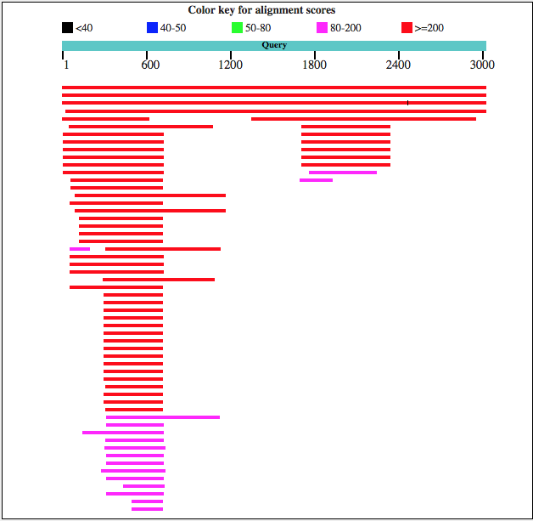
Color key represents alignment scores – higher score = higher similarity. Red means it is the most similar, followed by pink.

- What is the bit score, E-value and query coverage values of the first ten hits of the BLAST results? Copy the table that appears to capture the information.

The bit score or Max score is calculated from the alignment and normalized using the scoring matrix used for the BLAST search (https://www.ncbi.nlm.nih.gov/books/NBK62051/)

- Among these ten results, which represents an ortholog in another close species?

Bacteroides salanitronis DSM 18170 (highlighted in table in Q4 – other hits above this are the same species)

- There are some entries with significant E-values (low E-values). Are these all best matches to the entire query sequence? How would you pick the best match between the query and subject?

The first three hits in the table match genes in different strains of Bacteroides thetaiotamicron. The fourth hit matches genes in a different species. All these hits have high matching scores, high query coverage and low E-values. These criteria together are used to pick the best matches.

The fifth hit titled Bacteroides thetaiotomicron neopullulanase is not a good match due to a low query coverage (20%).

- How would you identify a closely related species to your query sequence?

The criteria used for identify closely related species is High bit score, low E-value and a high query coverage. In addition, query and subject length should match with few gaps in the sequence alignments.

