This is an archived version of an online document available here. Other materials mentioned here that have been archived are indicated by {the file title} in curly brackets immediately following the link to the online version.

DCS 105 Calling Bull in a Digital World Bates College Winter 19
Dr. Diaz Eaton cdeaton@bates.edu, Pettengill G19 MW 2:40 - 4 Carnegie 225
Office hours: Tuesdays 2-4, Thursdays 1-2:30

Course Description:
Our world is rife with misinformation. This is a course that will hone your digital citizenship skills. It is about "calling b***s*** ": spotting, dissecting, and publicly refuting false claims and inferences based on quantitative, statistical, and computational analysis of data. We will explore case studies in policy and science; possible examples include food stamps, caffeine, improving traffic, and gendered mortality rates. Information skills fostered in the course includes spotting misinformation, causal fallacies, statistical traps, data visualization, big data, interpreting scientific claims, fake news and social media, and refutation techniques. This course will introduce students to data analysis and visualization with R. As an introduction to programming course, everyone is welcome.

Acknowledgements:
Much of the course description, design, syllabus, and educational materials have been adapted from “Calling Bullshit,” callingbullshit.org, by Bergstrom and West. DCS has a commitment to the use of open educational resources and software in the journey of designing an accessible computing education.
This class is also supported by DataCamp:
“The most intuitive learning platform for data science. Learn R, Python and SQL the way you learn best through a combination of short expert videos and hands-on-the-keyboard exercises. Take over 100+ courses by expert instructors on topics such as importing data, data visualization or machine learning and learn faster through immediate and personalised feedback on every exercise.” (link to course, link to FAQs/troubleshooting)

DCS Values Statement (under active construction):
The primary purpose of Digital and Computational Studies is to bridge the liberal arts education to computing and the digital world. In this, we are committed to actively creating digital and computational spaces that are radically inclusive. Our core commitment is to integrating equity and social justice throughout our curriculum, and engaging students in metacognition to support this work. Digital and Computational Studies experiences also include:
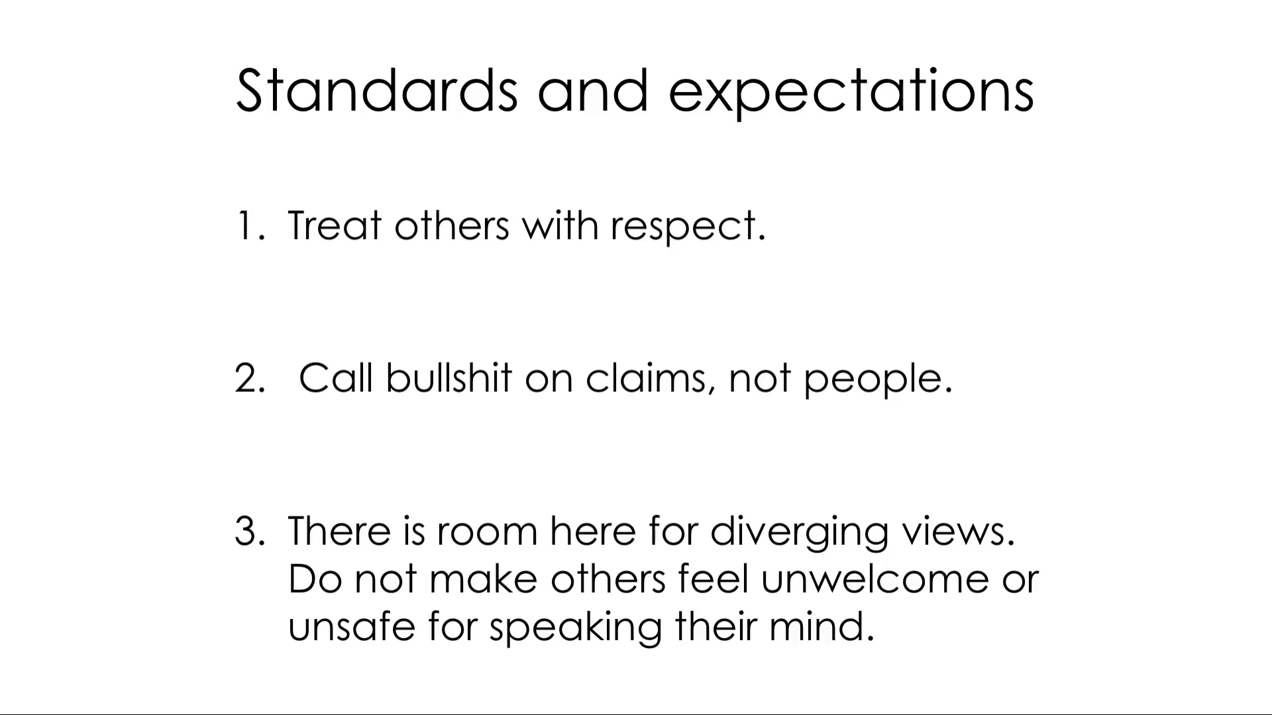
- Community engagement - inspiration from and engagement in our local, cultural, and/or disciplinary communities, including interdisciplinary and between community work and communication;
- “DCS design” - design, modeling, and application with intentional compassion;
- Play - providing a welcoming community that encourages, creativity, imagination, growth mindset, revision, and experimentation;
- Ethical Co-Leadership - inviting collaborators to share strengths, build on weaknesses, and contribute to a broader shared understanding.

Learning Objectives:
At the end of this course, we expect students will be able to:
- Metacognitively engage in contemporary issues in equity and social justice related to their digital world, community, and identity. (Think about this class every time you hear the news, make daily choices, or even put your shoes on.)
- Play with computational ideas creatively, using a growth mindset which values revision and experimentation and demonstrate community leadership skills as a collaborator that shares strengths, builds weaknesses, and contributes to a broader shared understanding. (Participate in teamwork in respectful ways that allow people to relax and play with ideas).
- Recognize and translate between algebraic, numeric, visual, and verbal representations of data. (Remain vigilant for bull contaminating your information diet and recognize said bull whenever and wherever you encounter it.)
- Design models of and computationally investigate ideas in practical and professional spaces through and communicate the process and meaning to others. (Figure out for yourself precisely why a particular bit of bull is bull, provide a statistician or fellow scientist with a technical explanation of why a claim is bull, and provide your “casually racist uncle” with an accessible and persuasive explanation of why a claim is bull.)

Course Materials required:
Books: Observe, Collect, Draw: A Visual Journal by Lupi and Posevec (colored pencils will also come in handy for this)
Technology: You should have a laptop with RStudio installed that you can bring on some project days. If you have any difficulties with accessing one, let me know, or feel free to borrow one from the library and use qubeshub.org or catapult.bates.edu to access R. DataCamp has its own built-in interface.

Grade:
30% Weekly reflection blog
20% Data journal checks
30% In-class engagement/active learning
20% Final Project

Course activities:
- Reflections: We have classes Monday and Wednesday afternoons. I will assign out of class work each week that will inform the week’s activities. Before Monday’s class, prepare for discussion with peers, engage in class for all class activities, and then at the end of the week, due each Friday, write a 1-pg “Reflection” blog post about the week.
- Data Journal: Set aside a little time each day to work on your Data Journal. I will check it every three weeks (on a Wednesday) on a completion/effort grade & return by the following Monday. Some of the data journal assignments will require recording for a week.
- Active Learning: We will be having regular discussions on readings and “Figure of the Day” as well as case studies & DataCamp tutorials that involve computation, so attendance is important. In-class assignments will be graded on completion, and if you need extra time to complete an in-class project, have it checked off next class, at the next professor office hours, or at the next TA session.
- Final Project: You will also have a final project that asks you to explore a topic/current event/data/meme of your own and use the tools you’ve learned in the semester to determine if it is bull and then implement a communication strategy.

How course activities support learning:
Guiding Course Principles | CB  R | CB  V | CB  CS | F ot D | DJ | DC | Reflect | FP | GW
Content Goals
Bullshit | X | X | X |  |  |  | X | X | X
Data Visualization |  |  | X | X | X |  |  | X
Introduction to R |  |  | X |  |  | X |  | X
Metacognitive Goals
Reflective/Analytical Thinker | X |  | X |  |  |  | X | X | X
Digital Citizenship |  |  | X |  |  |  | X | X | X
Empowered through Programming |  |  | X | X | X |  | X | X
DCS Values
Community Engagement |  |  | X | X |  |  |  | X
DCS Design | X | X | X |  |  | X |  | X
Play |  |  | X | X | X |  | X | X
Equitable Co-leadership |  |  |  |  |  |  | X |  | X
CB: Calling Bull (R Readings, V Videos, CS Case Studies), FotD: Figure of the Day, DJ: Data Journal, DC: DataCamp, Reflect: Weekly Reflections, FP: Final Project, GW: In-class Group Work and Discussions

Resources:
It is my goal to create a learning experience that is as accessible as possible. If you anticipate any issues related to the format, materials, or requirements of this course, please meet with me outside of class so we can explore potential options. Also, if you have already been approved for accommodations through the Office of Accessible Education (link), please meet with me so we can develop an implementation plan together.

If you do need need to see me, please stop by during office hours or e-mail me for an appointment. During office hours, I will be either in the DCS student space in Pettingill, G04, or my office, G19. Academic support resources are also available through Academic Resource Commons (Writing), Math and Stats Workshop (Matlab/Octave & LaTeX), the Library (R), and Curricular Resources and Computing (link). DCS is also working to provide coordinated peer support, and we welcome your feedback and collaboration on these efforts.

Contract:
This syllabus serves as a contract between student and teacher. I reserve the right to change the syllabus schedule as needed due to class cancellations, adjustments in course pace, etc. If you have any concerns about its content, please talk to me as soon as possible.

Homework and Resource List:
Note: Videos are V#, where # is the week in the link & R# are readings, where the # is the week as indicated in this link and a * indicates that at least one “firewalled” reading is available on Lyceum, Case Studies are at this link unless otherwise indicated, DataCamp tutorials are at this link (need to use your bates.edu email for your account and this invitation link to get free access). WEEKLY REFLECTIONS DUE EACH FRIDAY STARTING Week 2 - Due 1/18/19 (Rubric {Reflection Rubric CB.docx}).
Week | Theme | Readings & Videos | Case Studies & Projects | Data Camp | Data Journal
1-3 | Bull: the 5 Ws |  |  | Introduction | Seeing data
1 | Introduction to bullshit | W: V1, R1 | First Day ?s  {Callin Bull First day questions.docx}  BS inventory | Introduction to R  Hint: take notes on commands used as a reference guide | Complete the section “Learning to see”section. Due Wednesday, Week 3.
2M | Spotting bull  Note: no class W 1/16 | M: V2, R2 | Food Stamp
3W | Note: no class 1/21 MLK  Ecology of bull | W: R3 | Caffeine &  Caffeine-Free in R {Caffeine case study.docx}
4-6 | Unintentional BS |  |  | Programming | Data thinker
4 | Causality | V3, R4 | Traffic &  Storks and Babies in R {Correlation.docx} | Intermediate R | Complete 5 one sitting and 1 one day activities.  Due Wednesday Week 6 (2/13).
5 | Statistical traps | V4, R5* | Musicians and mortality  Mammograms {Prosecutor's Fallacy and Mammograms.docx}
6 | Big data | V5, R7* | Criminal ML &  ML on Sexual Orientation
Break February 18 - 22
7-9 | Intentional BS |  |  | Data viz in R | Data collector
7 | Visualization | V6, R6* | Data Viz Rubric {Data viz rubric.docx}  Track and field case study & Project in R {Track and Field.docx} | Introduction to Data Visualization with ggplot2 (Pt 1)  Quick reference sheet | Complete 3 activities total from the “five days/one week” sections. Due Wednesday, Week 9.
8 | Publication bias | V7, R8 | Gender Gap Case Study and Gap Project in R
9 | M: Predatory publishing and scientific misconduct  W: Ethics of Calling Bull | M: V8, R9  W: R10 | P-hacking
10-12 | The bull is in your court |  |  | Choose your adventure | Visualizing data
10 | Fake news | M: V9, R11  W: Bring your BS for project | Final Project proposal {CB Final Project.docx} | Complete an additional 2000 XP points (should bring total to over 20,000) | Complete 4 activities from the “visual language” section
11 | Refuting bullshit | V10, R12 | Final project Refute rubric {Refuting BS Rubric.docx}
12 | EPortfolios and Peer Review - Guest Dr. Wade, ARC  M: Eportfolios  W: Peer Review | Bring your project drafts | Final project  work time  Example eportfolio
Finals week |  |  | Final project due

