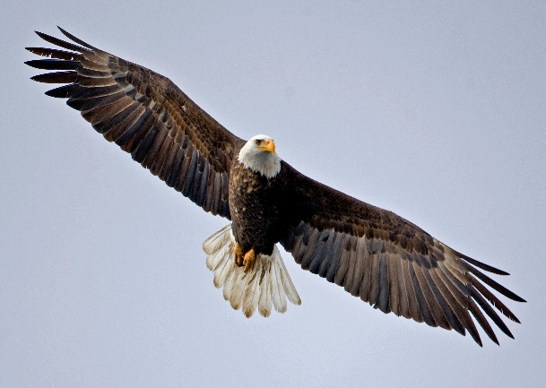
ISSUES : DATA SET
Exploring the population dynamics of wintering bald eagles through long-term data

Julie Beckstead^{1,3}, Alexandra N. Lagasse¹, and Scott R. Robinson²

1 - Department of Biology, Gonzaga University, Spokane WA, 99258
Photo 1: Adult bald eagle flying in a winter sky. Photo by Tom Michalski.

2 - Wildlife Biologist, Retired, Bureau of Land Management Coeur d'Alene Field Office, Coeur d’Alene, ID 83815.

3 - Corresponding Author: Julie Beckstead (beckstead@gonzaga.edu)

THE ECOLOGICAL QUESTION:
How does a bald eagle population change over time at a winter migratory stopover and which factors influence its abundance?

ECOLOGICAL CONTENT:
Bald eagle biology, conservation biology, endangered species, population ecology, and migration ecology (stopover)
GOAL:
You will generate questions about bald eagle numbers influenced by weather and food availability. You will then use R to compile the data in a graphical form and to run statistical tests to answer their questions.

SOURCE:
U.S. Department of the Interior, Bureau of Land Management, Coeur d'Alene Field Office, archived data.

OVERVIEW OF THE ECOLOGICAL BACKGROUND
The availability of long-term data on bald eagles (Haliaeetus leucocephalus; Photo 1) provides an opportunity to study the population dynamics of this culturally and ecologically important bird. In conservation biology, the bald eagle provides a unique example of a species that has overcome the imminent threats of extinction (Grier 1982). Because of its endangered status in the early 1970s (Buehler 2000), several agencies and biologists initiated long-term surveys. Some of these surveys have been implemented at a local scale, and others are nationwide, such as the Midwinter Bald Eagle Survey (Steenhof et al. 2008). Some of the data from these long-term surveys have been analyzed (Arizona see Grubb 2003, Western Washington see Dunwiddlie and Kuntz 2003, and Glacier National Park see McCelland et al. 1994), but other data sets have yet to be fully investigated.

Several of these long-term data sets have been gathered during the winter migration when bald eagles aggregate at stopover sites on lakes and rivers along their migration routes. In the U.S., the eagles move from their summer resident locations in the north towards the south. The primary hypothesis for this movement is that the food supply (primarily fish and, to a lesser degree, ducks) becomes less available as winter approaches and drives the eagles south (McClelland et al. 1994). Several factors influencing bald eagle populations along their migration stopovers have been studied, including weather (Grubb 2003), feeding site characteristics (Dunwiddie & Kuntz 2003; Mull and Wilzbach 2007) and human disturbance (Stalmaster and Kaiser 1998; Dunwiddie and Kuntz 2003). Long-term patterns may also differ among adult versus immature eagles (see McClelland et al. 1994; Dunwiddie and Kuntz 2003; Grubb 2003).
The data sets we use in this activity come from the Bureau of Land Management in Northern Idaho. Since 1974, they have counted migrating bald eagles every midwinter at Lake Coeur d’Alene. The eagle counts are recorded on a weekly basis at several sites on the northeast end of the lake. The adult and immature eagles are counted separately. Additional data on the kokanee salmon (Onorhynchus nerka) abundance in the lake, weather events, and site characteristics have been assembled.

References:
Buehler D. A. 2000. Bald Eagle (Haliaeetus leucocephalus). In A. Poole and F. Gill, editors. The Birds of North America. Philadelphia. No. 506, The Birds of North America, Inc., Philadelphia, PA.
Dunwiddie P. W., and R. C. Kuntz II. 2001. Long-term trends of bald eagles in winter on the Skagit River, Washington. The Journal of Wildlife Management 65:290-299.
Grier J. W. 1982. Ban of DDT and subsequent recovery of reproduction in bald eagles. Science 218:1232-1235.
Grubb T. G. 2003. Wintering bald eagle trends in Northern Arizona, 1975-2000. The Southwestern Naturalist 48:223-230.
McClelland B. R., L. S. Young, P. T. McClelland, J. G. Crenshaw, H. L. Allen, and D. S. Shea. 1994. Migration ecology of bald eagles from autumn concentrations in Glacier National Park, Montana. Wildlife Monographs 125:3-61.
Mull K. E., and M. A. Wilzbach. 2007. Selection of spawning sites by coho salmon in a Northern California stream. North American Journal of Fisheries Management 27:1343-1354.
Stalmaster M. V., and J. L. Kaiser. 1998. Effects of recreational activity on wintering bald eagles. Wildlife Monographs 137:3-46.
Steenhof, K., L. Bond, and L. L. Dunn. 2008. The midwinter bald eagle survey results and analysis 1986-2005. U.S.Geological Survey, National Biological Information Infrastructure, and Northwest Alliance for Computational Science and Engineering. Available on-line at http://www.nacse.org/nbii/eagles. (Accessed November 22, 2010.)

INSTRUCTIONS
This data set explores factors affecting the population numbers of bald eagles (Haliaeetus leucocephalus; Photo 2) surrounding Lake Coeur d’Alene, Idaho. The Bald eagle is a large bird of prey that demands our attention by its physical features, its history of near extinction, and its dynamic population seen today.

Background Information:
The population trend of the bald eagle during the past 70 years provides a history with several important lessons. After World War II, the insecticide, dichlorodiphenyl-trichloroethane (DDT), was allowed for widespread agricultural use. Despite its effectiveness in killing insect pests on crops, the chemical accumulated in the body tissues of bald eagles (through biomagnification), making the birds unhealthy and causing them to lay thin-shelled eggs that broke as soon as the parents sat on them to begin incubation. The numbers of bald eagles in the contiguous United States, which were already declining due to hunting, plummeted as a result. The bald eagle was listed as endangered under the Endangered Species Act of 1973, and this protection, combined with the national ban of DDT in 1972, is credited with leading to the recovery of these birds.

Bald eagle numbers not only vary over historical time, but they also vary across the landscape with changes in the seasons. Like many birds, most bald eagles migrate in the winter in search of food. The primary food source for bald eagles is fish, and the eagles need open water to access the fish, which in many locations consists of spawning salmon at the shallow edges of lakes and streams. Once the lakes and streams freeze over, the eagles have to use an alternative food source (i.e., carrion such as dead deer or elk) or go elsewhere. Bald eagles will also feed on ducks, although not as frequently as fish. During the migration the eagles follow a route with several stopovers at lakes and streams along a southward corridor. The bald eagles travel individually, and although a given eagle may spend only a week or two at a stopover, collectively the eagles may be present for several months. Although the birds travel as individuals, once at a stopover, they will roost together in the evening (i.e., location were eagles gather to sleep for the night) and perch together in the same or adjacent trees.

Because of its endangered status in the early 1970s, several agencies and biologists initiated long-term surveys. Some of the surveys are ongoing nationwide surveys, such as the Midwinter Bald Eagle Survey, and others are local surveys such as the data set that is the focus of this activity.

Since 1974, just two years after the ban on DDT, the Bureau of Land Management in Northern Idaho has counted migrating bald eagles every winter. The bald eagle counts are recorded on a weekly basis at eleven sites around Wolf Lodge Bay on Lake Coeur d’Alene in the Pacific Northwest (Figure 1). The eagles stop at Lake Coeur d’Alene because of the availability of kokanee salmon, which is a land-locked strain of sockeye salmon (Onorhynchus nerka). The salmon live to about three years of age and then spawn in November or December, dying immediately after spawning and leaving a large number of carcasses in the shallow water for the eagles to feed on. The biologists go out by car and count the number of eagles on perch trees or flying at these sites. The adult and immature eagles are counted separately. The sites are usually visited once per week in the morning from mid-November to the beginning of February with the highest numbers of eagles usually being present during December. In addition, the biologists record weather conditions, human activity at each site, salmon abundance, and various other factors that could influence the counts of migrating eagles.
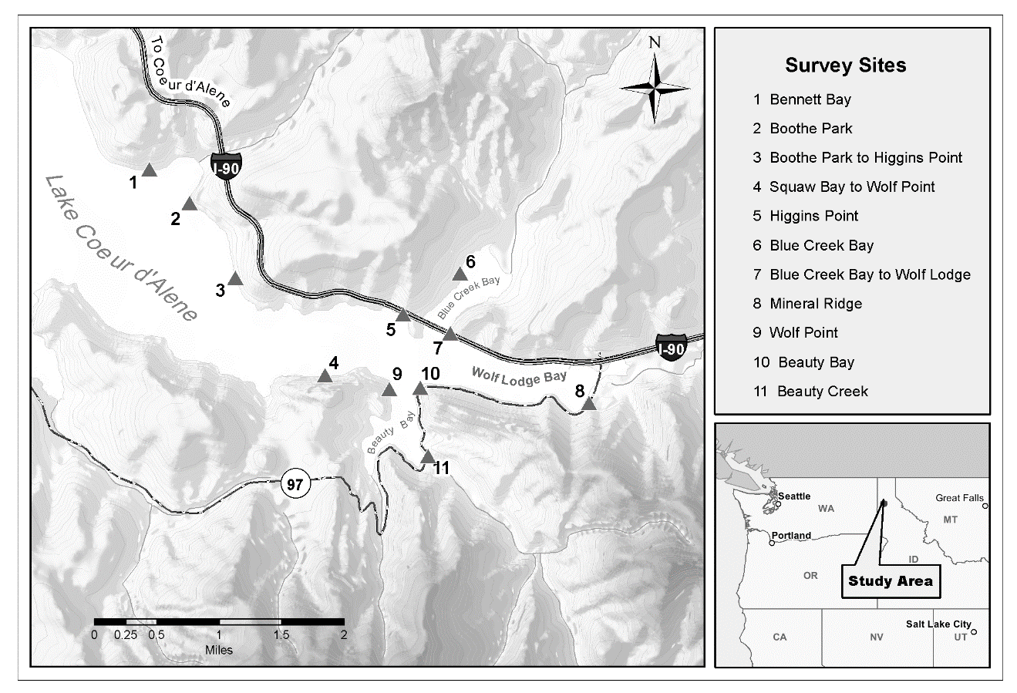
Figure 1: Map of the study area in the Pacific Northwest (United States) and the bald eagle winter survey sites along Lake Coeur d’Alene, Idaho.

Instructions:

Part I: How does the bald eagle population at a winter stopover change over three decades?

1. What is the difference between the dependent variable versus the independent variable?

2. You already know the question we want to ask about bald eagle numbers over the last thirty years since the ban on DDT, so make a prediction.
- Do you think there are more migrating bald eagles at Lake Coeur d’Alene? Less? Will the numbers fluctuate over time?
- Why did you make this prediction?
When making a prediction or hypothesis you are making assumptions for factors that will not vary with your treatments. For example, you are assuming that the eagles will migrate along a similar path each year.

3. To answer the question, you need to determine the data needed (i.e., experimental design). There are different types of experimental approaches, such as manipulative (you manipulate the independent variable and measure the dependent variable) and observational (you measure a response in nature, dependent variable, and nature provides the manipulation, independent variable). We are dealing with the latter situation. Complete the research proposal worksheet using your resources.

Once you have completed the research proposal with your questions and hypothesized graphs,

4. Import the eagleData.xlsx into R and graph the change in eagle population over time (hint: you will only be using Year and Peak Eagle Number), using your proposal to assist you. What does your graph say or what is the pattern that your data shows? What is your interpretation of the data pattern? Was your prediction accurate? Do the data support your hypothesis?

Part II: How do salmon abundance and December temperatures influence bald eagle numbers?

1. In the .xlsx file you will notice two more columns of data: one for salmon numbers and one for December temperatures at Lake Coeur d’Alene.

2. Create a graph that shows the relationship between December temperature and Peak Eagle Number. Compare this graph with the original eagle over time graph. Do you see any patterns that may help you to better understand the data?

3. Create graph that shows the relationship between salmon numbers and Peak Eagle Number. Compare this graph with the original eagle over time graph. Do you see any patterns that may help you to better understand the data?

4. Perform the appropriate statistical analyses to determine if there is a relationship between December temperatures and salmon numbers as they relate to bald eagle numbers.

Additional Questions:
1. Some people may argue that the bald eagle population is definitely recovering based on these data. Do you agree? Why/why not? Also, do you expect these trends to be the same at all sites within Northern Idaho? At sites in adjacent states? During the current decade or in future decades?

2. Explain the relationship between bald eagles and salmon abundance. Is it possible that there are other factors at work? If so, what do you think they are? Based on your results, what would you predict for the bald eagles in the future?

3. Explain the relationship between bald eagles and December air temperatures at Lake Coeur d’Alene. What other weather factors might be at work, and what impact would these have on the migrating eagles?

4. What additional questions would you propose to study to further examine bald eagle populations over time? Come up with at least 3.

5. Based on these results, what would you suggest to wildlife managers that want to ensure their bald eagle populations continue to show increases?

What you will hand in:

- Proposal page, with table filled out and graphs sketched with your predictions
- Three graphs (with proper axis labels and stand alone captions): bald eagle population numbers through time, temperature and bald eagle numbers, and salmon numbers and bald eagle population.
- Statistical analyses to help you explain any patterns there might be in the data you have graphed.
- Answers to questions in Part 1 and Part 2, and the 5 additional questions

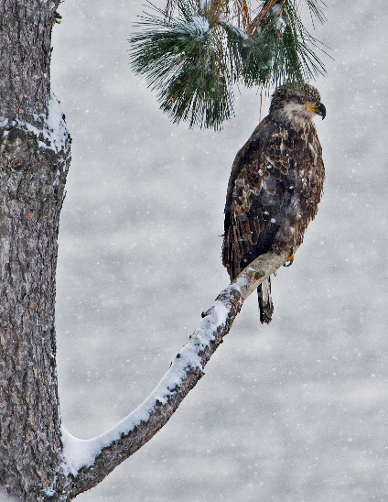
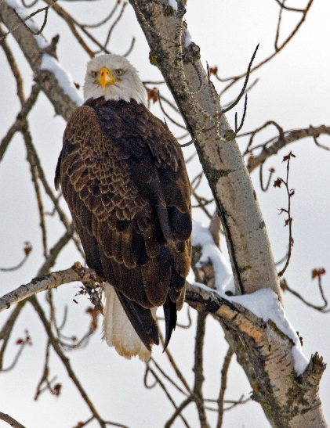

Photo 2. Adult bald eagle (left) with distinctive physical features perched in a cottonwood tree and an immature bald eagle (right) with a mixture of brown and white plumage in the winter environment. Photo by Tom Michalski.

Resources for Further Information:

- Stalmaster M. V. 1987. The Bald Eagle. Universe Books, New York.
Book on the history and ecology of the bald eagle

- http://www.fws.gov/Midwest/eagle/recovery/biologue.html
U.S. Fish and Wildlife Service’s bald eagle fact sheet

- https://www.epa.gov/ingredients-used-pesticide-products/ddt-brief-history-and-status
EPA Information on DDT

- https://idfg.idaho.gov/old-web/docs/wildlife/nongame/leafletEagle.pdf
Bald eagles in Idaho (Idaho Fish and Game)

- http://www.llbc.leg.bc.ca/public/pubdocs/bcdocs/167109/wr62.pdf
Status of the bald eagle in British Columbia

- http://ocid.nacse.org/nbii/eagles/
Midwinter Bald Eagle Count Web Site conducted from 1986-2005 along 746 routes in 43 states

COPYRIGHT STATEMENT
The Ecological Society of America (ESA) holds the copyright for TIEE Volume 7, and the authors retain the copyright for the content of individual contributions (although some text, figures, and data sets may bear further copyright notice). No part of this publication may be reproduced, stored in a retrieval system, or transmitted, in any form or by any means, electronic, mechanical, photocopying, recording, or otherwise, without the prior written permission of the copyright owner. Use solely at one's own institution with no intent for profit is excluded from the preceding copyright restriction, unless otherwise noted. Proper credit to this publication must be included in your lecture or laboratory course materials (print, electronic, or other means of reproduction) for each use.

