Exaggerated Traits and Breeding Success in Widowbirds: A Case of Sexual Selection and Evolution Teaching Notes

By Katie Northcutt
Biology Department, Mercer University, 1501 Mercer University Dr. Macon, GA 31207; northcutt_kv@mercer.edu

Course Information
Department: Biology Dept.
Level: Lower Undergraduate (first introductory course in the major)
Course type: Lecture, lab, and recitation
Students: Majors (and pre-health students)
Number of Students: 24

Module Information
Original Module Name: Exaggerated Traits and Breeding Success in Widowbirds: A Case of Sexual Selection and Evolution
Link to Original: https://qubeshub.org/qubesresources/publications/925/1
Teaching Notes
How it fit into the curriculum:
- I used this case study about a month into the course, at the very end of our unit on evolution. We had talked extensively about mechanisms of evolution, and this allowed us to explore sexual selection more thoroughly.

Implementation of the case study:
- I did not make any changes to the case study. We did this in the recitation part of the course. Students worked on this case study in pairs, and I split it into three segments (parts I and II, part III, and part IV). Before moving on to the next segment, we discussed the previous segment as a class.

Assessment:
- Students turned in their answers to the case study questions, and I went over them to make sure that there were no misconceptions.
- On the evolution exam, I asked students a short answer question (see next page) that required them to interpret data and also use their knowledge of experimental design and data interpretation (that we had discussed previously in the course).

Exam question: The graph to the right is from the widowbird case study. The researchers went into widowbird habitats, and for each male that they encountered, they measured the length of his tail and the number of active nests (with eggs) in his territory.
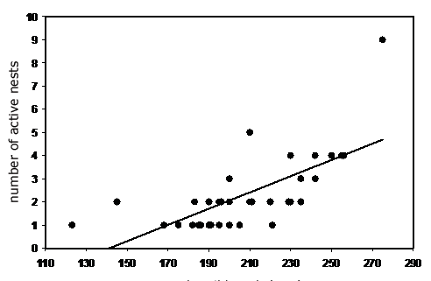

a) What kind of study does this represent? (2 pt.)
Answer: An observational study
b) What conclusion can we draw from these data (think about your answer to part a as you word your answer)? (2 pt.)
Answer: Male tail length and the number of active nests are positively correlated with one another, but we can’t conclude that there is a causative relationship between the two variables.
c) Even though the number of active nests vary, these researchers found that tail length was not related to the total number of nests in a male’s territory or how effectively he is able to defend his territory. Given this additional information, is intersexual or intrasexual selection most likely to be responsible for long tail lengths in males of this species? Briefly (in one sentence) explain your answer. (2 pts.)
Answer: Given that the researchers found that tail length was not associated with the ability of males to gain more resources, this is most likely a case of intersexual selection (females were mating more often with males with longer tails).

- On the Final Exam, I asked the following short answer question:

Final Exam Question: You are studying a group of blue-footed booby birds (they have bright blue feet). You want to know if this trait is a product of natural selection or sexual selection. Design a set of experiments that would allow you to make this conclusion. (4 pts.)

How it went:
- Overall, it went well and students were very engaged.
- Most students did very well on the exam question soon after the case study. Performance on the final exam question was also good (about 25% of students had a very good answer that involved manipulating foot color and measuring mating success and survival; about 50% of students designed a correlational study looking at the relationship between brightness of foot color and mating success/survival; the final 25% did not design an appropriate study to answer this question).
- Part III initiated a student discussion about ethics in research design due to the tail length manipulations. I did not expect this, but was very excited that students were eager to have this discussion.
- We spent a LOT of time on parts III and IV (data analysis). In total, it took about 2.5 hours to get through this case study. Students definitely felt more confident interpreting graphs at the end, but it took a long time for them to work through them.

Preparation:
- I spent a few hours preparing for the case study. I didn’t have to prepare anything, but just had to make sure that I was very comfortable with the case study, reviewed others’ teaching notes, and spent time anticipating student questions and pitfalls.

Using the case study in the future:
- I definitely plan to use this case study in the future, and do not plan to make any changes. I now know how much time to allot.

