ASSESSMENT QUESTIONS FOR BIOGEOGRAPHY MODULE

1. How would the proximity of the island (near/far) effect the above graph. Assuming the graph is representing the dynamics on an island that is “near”, draw the curve that would represent the dynamics of an island that was “far” by drawing a dotted line.

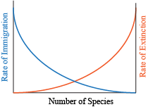
Figure: Shmoop Editorial Team. (2008, November 11). Biology Island Biogeography - Shmoop Biology. Retrieved May 29, 2019, from https://www.shmoop.com/biogeography/island-biogeography.htm

2. A. What were your original hypotheses regarding island biogeography?

B. Were they supported by the data that we collected during the island biogeography exercise? Why or why not?

C. What did you learn during this exercise that you did not know before?

3. Large islands will generally have ________________ species and _________________________ extinction rates compared to small islands.
a. more, higher
b. more, lower
c. less, higher
d. less, lower
e. none of the above

ASSESSMENT QUESTIONS USED THAT CAME FROM ORGINAL ASSIGNMENT:

1.
Rank the following islands in terms of expected genetic diversity (most diverse to least diverse).
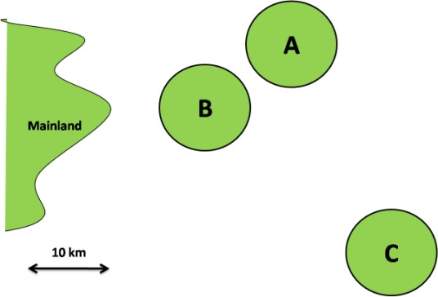
- A, B, C
- A, C, B
- B, A, C
- B, C, A
- C, A, B
- None of the above

2.
Which of the following reserve designs would most likely maximize species and genetic diversity?
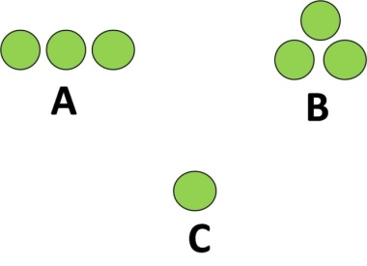
- A
- B
- C
- A and B
- None of the above

3.
Which reserve design would maximize genetic diversity?
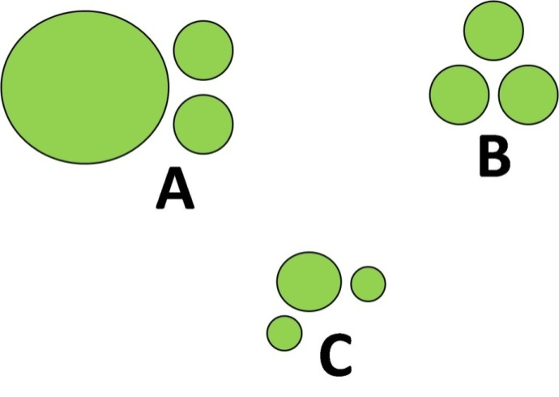
- A
- B
- C
- A and B
- None of the above

