Exploring how climate will impact plant-insect distributions
and interactions using open data and informatics

- Mac and PC Instructions for Downloading RStudio -

To download R Studio
- Go to www.rstudio.com
- Under RStudio, click Download
- On the next page you will see pricing options – our needs will be satisfied by the RStudio Desktop open source license for FREE. Click Download under that option – see figure below for clarification.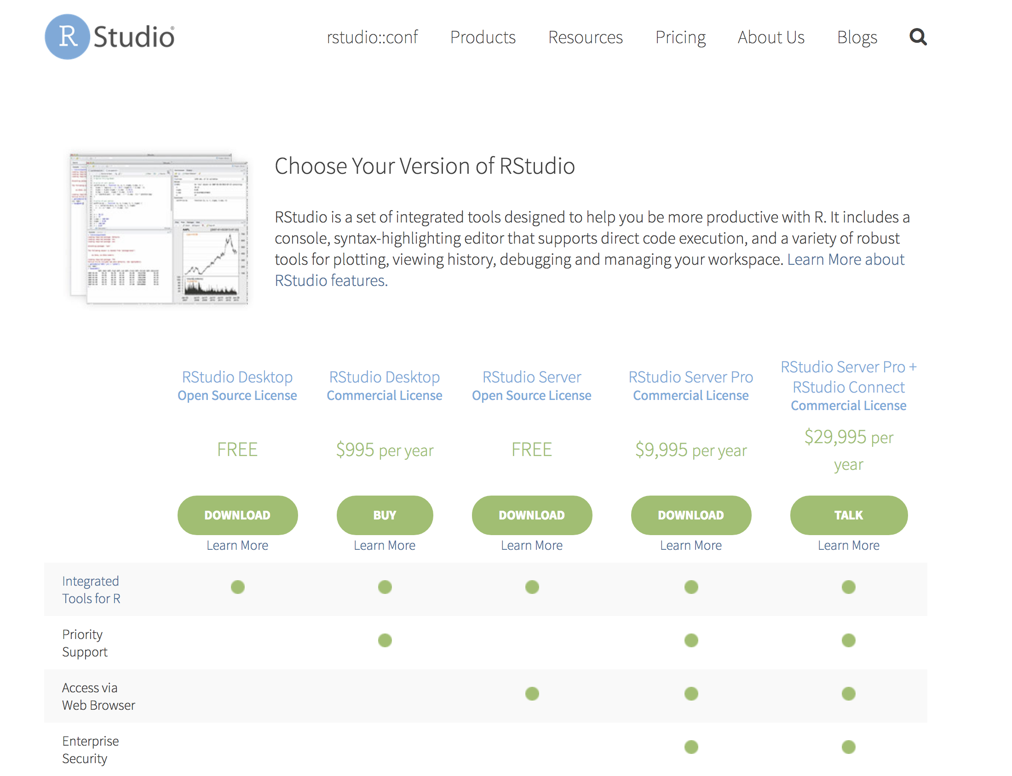

- This will take you to the bottom of the page. Choose the link that matches your operating system – likely either RStudio1.1.383 – Windows Vista/7/8/10 OR RStudio1.1.383 – Mac OS X 10.6+ (64-bit). For windows users you may be asked to save the file. Note the version number (e.g. 1.1.383) may be different, but the lesson should work regardless.
- Follow the directions below that correspond to your operating system.

Continuing the download of RStudio on a Mac
- Open the RStudio file you just downloaded from your Downloads folder.
- This will open a window with two icons – one for RStudio and one which is a short cut to your applications folder. Drag the RStudio icon on to the applications folder icon to copy the program.

Continuing the download of RStudio on a PC
- Open the file you downloaded (e.g. RStudio1.1.383 – Windows Vista/7/8/10).
- Follow the prompts of the wizard that appears and use all of the default settings.

Troubleshooting
- Mac users: https://youtu.be/cmj8Oi6PFe0
- PC Users: https://youtu.be/9-RrkJQQYqY

