Exploring how climate will impact plant-insect distributions
and interactions using open data and informatics

SP-2: Species Distribution Maps (SDMs) and Hypothesis
- Assignment -

- Example -

Student name

I. Butterfly species observation map: Papilio cresphontes
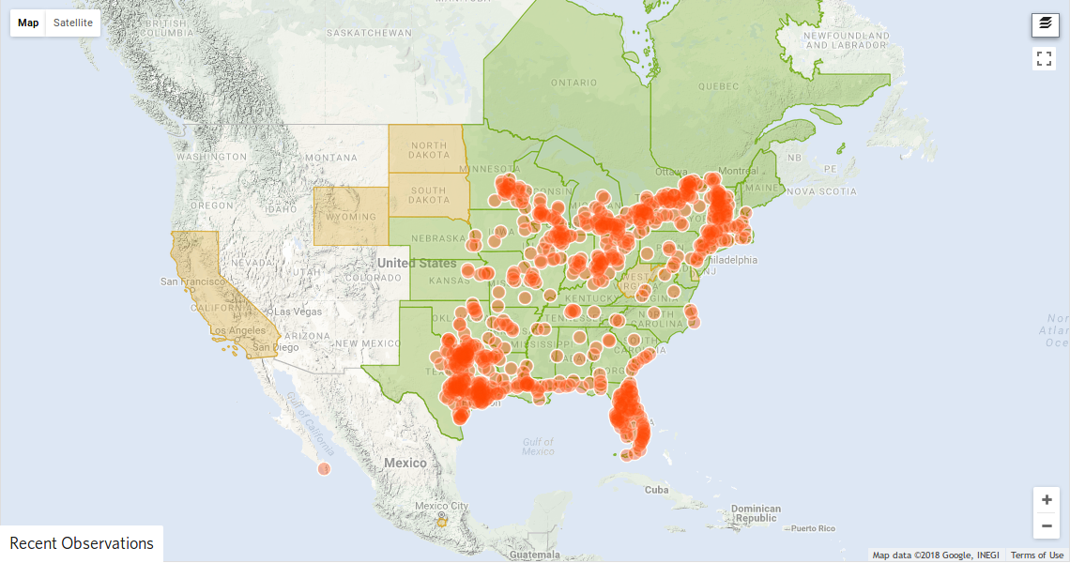
Figure 1. An observation map of Papilio cresphontes. The map was generated using research grade data from iNaturalist collected on 2018-02-01 (https://www.inaturalist.org/taxa/50072-Papilio-cresphontes). Each orange point represents a single observation made and submitted to iNaturalist.

II. Host plant species observation map: Zanthoxylum americanum

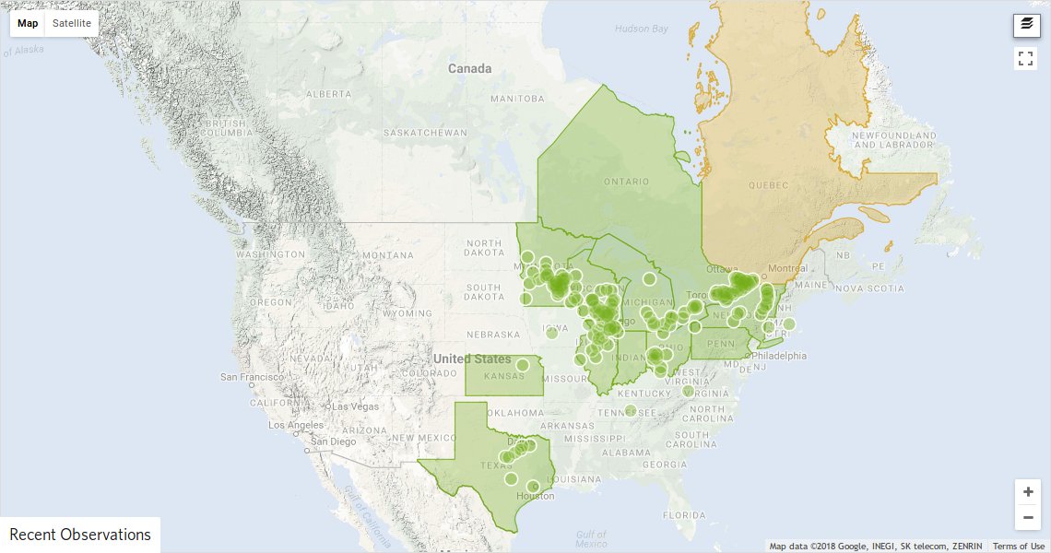
Figure 2. An observation map of Zanthoxylum americanum. The map was generated using research grade data from iNaturalist collected on 2018-02-01 (https://www.inaturalist.org/taxa/54836-Zanthoxylum-americanum). Each green point represents a single observation made and submitted to iNaturalist.

III. Butterfly Species Distribution Map: Papilio cresphontes
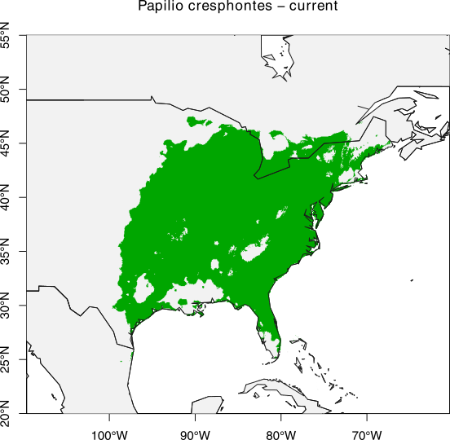
Figure 3. Species distribution model (SDM) for Papilio cresphontes for current climate conditions. SDM generated in R using research grade observation data collected from iNaturalist on 2018-02-01. Green area represents the projected current distribution of P. cresphontes.

IV. Host Plant Species Distribution Map: Zanthoxylum americanum
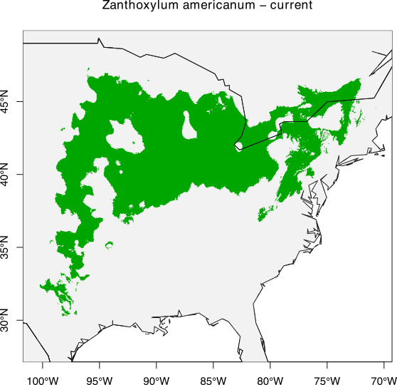
Figure 4. Species distribution model (SDM) for Zanthoxylum americanum for current climate conditions. SDM generated in R using research grade observation data collected from iNaturalist on 2018-02-01. Green area represents the projected current distribution of Z. americanum.

V. Comparison of Observation Maps to SDMs
In the case of both the the butterfly, P. cresphontes, and the host plant, Z. americanum, the SDMs proposed a wider distribution than the observation maps. Remembering that the SDMs are based on predicted models based on the observations, they suggest areas in which these organisms are likely found based on climate conditions. It is likely that these organisms occupy some or all of these predicted ranges as the observations are limited by where citizen scientists and experts have explored and observed these particular butterflies.

VI. Model Comparison of Distribution Overlap: Papilio cresphontes & Zanthoxylum americanum
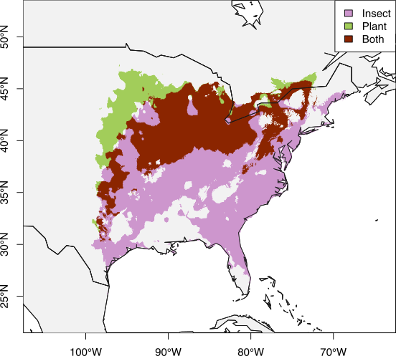
Figure 5. Species distribution models for Papilio cresphontes (pink), Zanthoxylum americanum (green), and area of overlap (red) for current climate conditions. Papilio cresphontes occupies 81.95% of the range of Z. americanum in this model. SDM generated in R.

Verbal description: Both P. cresphontes and Z. americanum have areas of their distribution in which they overlap, as well as areas of their distribution in which they exist independently. Zanthoxylum americanum has a distribution that spans from the midwest east to the Appalachian mountains. By comparison, P. cresphontes has a much broader distribution covering much of the eastern United States with the exception of northern Main and parts of the southeastern United States. Both organisms can and do exist independently of one another demonstrating that P. cresphontes has more than one host plant.

VII. Working hypothesis for effects of climate change on this plant-insect interaction
If the climate continues to warm, Papilio cresphontes will expand into northern Iowa and Minnesota, where its larval host plant, Zanthoxylum americanum currently exists.

VIII. Rationale for your hypothesis. The current range of Papilio cresphontes suggests that low winter temperatures (an abiotic component of the environment) prevents it from using larval host plant resources in northern Iowa and Minnesota. If the winter temperatures in those regions increase, it may allow P. cresphontes to survive the winter there and expand its range.

IX. Make a prediction as to what component (biotic or abiotic) will have the greatest impact on the distribution of your butterfly 50 years into the future.
Temperature (abiotic) will likely have the greatest impact on Papilio cresphontes in the future, as there are larval host plants available north of its current range. It is possible that a northern expansion of Papilio cresphontes may be limited in the eastern part of its range, as it already appears to extend to the northern limit of the range of Zanthoxylum americanum. However, if Z. americanum also expands its range northward, P. cresphontes may follow it.

