Name: ____________________
Investigating human-induced unnatural selection in African elephants (Loxodonta africana)

We will be working with a data visualization tool for this exercise. Launch the tool by going to https://mdllama.shinyapps.io/tusklessness/

Watch the video “Selection for Tuskless Elephants” in the main window, then work with your partner to answer the following:

1. Describe how the population of elephants in the video changed over time.

2. What phenotypic changes did the researcher notice in the population over time.

3. What has driven the changes in the population of elephants?

4. Given the changes in the population, do you think tusklessness is a heritable trait? Explain your reasoning.

Sex | N | Tuskless | % Tuskless
Male | 54 | 0 | 0%
Female | 81 | 41 | 51%

Table 1. Tusklessness in the registered elephants in Gorongosa National park, Mozambique.

5. The table to the right summarizes a recent census of the Gorongosa elephants by Dr. Joyce Poole.

a. Is tusklessness more common in male or female elephants?

b. Compare and contrast the advantages and disadvantages of having tusks in the absence and presence of poachers.
 | Advantages of having tusks | Disadvantages to having tusks
In the absence of poachers
In the presence of poachers
c. Are the advantages/disadvantages you identified in part b. the same or asymmetric in males and females? Explain.

d. Provide a hypothesis to explain the pattern observed in Table 1.

6. If you were to go back to this population in 100 years, predict how frequent tusklessness would be if…
a. there was no poaching…

b. there was another extreme poaching event…

Justify your reasoning:

How have other African elephant populations changed in response to poaching?

Read the additional material below the video (scroll down to view all of it). Together we are going to analyze data collected by Chiyo et al. (2015) (available from Dryad Data Repository). Recall from the summary that Chiyo et al. (2015) examined elephant tusk size in populations of elephants in Kenya and Tanzania from 1966-1968 and 205-2013. They collected tusk length (cm), tusk circumference (cm), shoulder height (cm) for elephants at two time points, 1966-1968 and 2005-2013.

7. Given what you have learned about the long-term impacts of poaching on elephant populations, make a prediction about changes in tusk size from the 1960s population to the 2010s population Chiyo et al. (2015) surveyed.

I expect that the elephants in the 1960s had… (circle one) larger smaller

… tusks compared to elephants measured in the 2000s, because:

Begin to explore the data using the data visualization tool. The data visualization tool has four headings in the menu bar on the left:
- Module: The website will automatically open to this heading. This has the introduction and background to the data exploration activity. If you need to refresh your memory about the Gorongosa elephant studies, migrate back here.
- Data: Here is where you will find the raw data from the Chiyo et al. (2015) study. You can further explore the data by sorting and filtering the data using the boxes under the column headings.
- Explore: This is where you can create visual representations of the data by dragging the variables you are interested in to the appropriate plot aesthetics. Choose your plot type and drag it to the top ‘Layers’. You can modify your axes, add a title, and a caption to your figures.
- Analyze: Summary statistics and simple statistical analyses, such as T-test, ANOVA, and linear regression, can be used to further explore the data set under this heading.
Creating Plots
8. Use the Explore tab to explore relationships between variables within your dataset.
- Click and drag the Variables (beige boxes on the left)you want to explore into the appropriate Plot feature boxes (green boxes). As you add a Variable to a Plot Feature the box will briefly change from green to red when your variable has been successfully incorporated. If you forget the variables you’ve assigned, you can click on the Plot Feature and the Variable will be listed below.
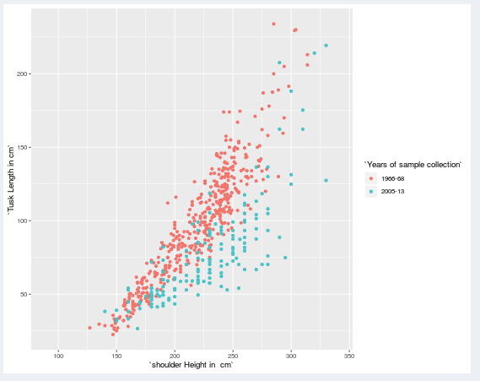
- You can make scatter, line, box and bar plots (and more). Select the Plot Type by clicking and dragging the icon for the plot type of your choice to the Plots Used area located just above the plot area. You can layer multiple data visualizations at once by dragging multiple plot types into the Plots Used area.
- Play around with the data set. To the right is an example of something you could create (Plot: scatter, x: shoulder height, y: Tusk Length, colour: Years of sample collection). Try this first and then explore and make your own.
- Working with your partner, use the Explore heading to create figures and explore the dataset.

Create a figure and then copy and paste your plot below. Be sure to write a short figure caption.

Insert your figure here:

Figure 1: Insert figure title and caption here

Answer the following about the figure you created:
a. What plot type did you create?

b. Why did you choose that particular plot type?

c. What variables did you compare?

d. What did you learn?

e. You can use the Analyze heading to further investigate your comparisons. Is there a statistical test that would be appropriate to further analyze your data? If so, do the test and report your results.

9. Compare your results with another group.
a. What did you learn from the other group?

b. What would you like to investigate further?

Generating Summary Statistics
10. Continue investigating the Chiyo et al. (2015) dataset by generating summary statistics:
- Click on the Analyze heading in the left menu bar and then select Statistical Summaries from the drop-down list.
- In the Analyze window, click in the "Compute Statistics for:" box and select the variable(s) you want to view. In this case, select shoulder height, tusk length, and tusk circumference.
- The Table window should now display several summary values for each of the variables you selected. For now, we are only interested in the mean values. To remove the other values, go to the "Statistics:" box and click the "x" marks to remove the other statistics.
- We are interested in how the height and tusk variables different between sexes and years. To group the data this way, click in the "Group by:" box and select sex. The table should now display the variable means by sex.

Create a table that shows the mean for each year by sex for tusk length (cm), tusk width (cm), and shoulder height (cm). Paste the table below.

Table 1: Insert your table title here:

Insert your table here:
Data Exploration
11. Create a figure to illustrate the differences in tusk length between your populations. Compare your figure to that created by the other group at your table.
Insert your figure here:

Figure 2: Insert figure title and caption here
a. Is there a significant difference between the mean tusk length of the individuals censused in 1966-1968 and 2005-2013? To examine this, use the Analyze heading >> Hypothesis test, and select Two-Sample T-test. Record your results below:

b. Create a figure to illustrate the differences in tusk circumference between your populations. Compare your figure to the one created by the other group at your table.
Insert your figure here:

Figure 3: Insert figure title and caption here
c. Is there a significant difference between the average tusk circumference of the individuals censused in 1966-1968 and 2005-2013? Using the Analyze heading >> Hypothesis test. Choose Two-Sample T-test and record your results below:

12. Recall from the video that the researchers focused on the importance of tusks. Using your analyses, answer the following questions.
a. In general, which population (1966-1968 or 2005-2013) had longer tusks on average?

b. Did males or females typically grow longer tusks? Are these results expected? Why or why not?

c. Does the difference in average body size strongly correlate with differences in tusk length over time? What does this suggest about selective pressure on tusk size?

13. Are your results from the Chiyo et al. (2015) data expected when taking into consideration the observations from other populations of elephants (like the Gorongosa population) and what you predicted earlier in the activity? Why or why not?

14. Consider the evolutionary effects of poaching on elephants.
- Do the changes in tusk length over time in males and females suggest that selection acts the same or differently on males and females? Explain.

- When considering sexual selection, do you think males are likely the competitive sex (typically competing with other males to gain access to more mates) or the choosy sex (where they have access to ample mates and only chose specific females to mate with)? Justify your answer.

15. Conclusions:
a. What are the short and long-term impacts of these changes on elephant populations?

b. While poaching may affect phenotypic changes in tusk length, is the population decline of concern? Why or why not?

References:

Chase, M. J., S. Schlossberg, C. R. Griffin, P. J. C. Bouché, S. W. Djene, P. W. Elkan, S. Ferriera, F. Grossman, E. M. Kohi, K. Landen, P. Omondi, A. Peltier, S. A. F. Selier, and R. Sutcliffe. 2016. Continent-wide survey reveals massive decline in Africa savannah elephants. PeerJ, 4:e2354

Chiyo, P. I., V. Obanda, and D. K. Korir. 2015. Illegal tusk harvest and the decline of tusk size in the African elephant. Ecology and Evolution, 5 (22): 5216-5229.

Chiyo PI, Obanda V, Korir DK. 2015. Data from: Illegal tusk harvest and the decline of tusk size in the African elephant. Dryad Digital Repository. https://doi.org/10.5061/dryad.h6t7j

