Population Ecology: Estimating Population Size
A central question in ecological studies is how many individuals are present in a population. A population is all of the individuals of the same species within an ecological community and we call this number, the number of individuals within the same species within a population (N). While most ecologists study more captivating and complex questions than this one, one can seldom conduct a study without answering this initial question. Ecologists study population size to see how populations fluctuate over time as a result of interactions within the population, between the population and other populations, and between the population and the environment. However, population data is also critical for conservation research.
What are some of the things that you can you learn from a population’s size? Well, a large population usually means high genetic diversity, which means the population will be more stable and less likely to go extinct. A low-density population or a population that is thinly dispersed over a geographic region may make mate finding more difficult. But a high-density population may have more intraspecific competition. For instance, look at this graph comparing population density and animal size. Consider: what does this graph tell you & how might this information be useful?

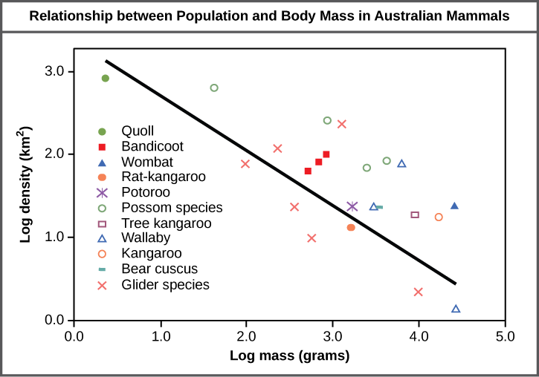

However, estimating population size goes beyond conservation. It can also be critically important to human health. For instance, during the Zika outbreaks, scientists carefully monitored and estimated mosquito populations in order to attempt to contain the spread of the virus. Here is the abstract from one such paper:

Background: Pathogen transmission by mosquitos is known to be highly sensitive to mosquito bionomic parameters. Mosquito mark-release-recapture (MMRR) experiments are a standard method for estimating such parameters including dispersal, population size and density, survival, blood feeding frequency and blood meal host preferences.

Methods: We assembled a comprehensive database describing adult female MMRR experiments. Bibliographic searches were used to build a digital library of MMRR studies and selected data describing the reported outcomes were extracted.

Results: The resulting database contained 774 unique adult female MMRR experiments involving 58 vector mosquito species from the three main genera of importance to human health: Aedes, Anopheles and Culex. Crude examination of these data revealed patterns associated with geography as well as mosquito genus, consistent with bionomics varying by species-specific life history and ecological context. Recapture success varied considerably and was significantly different amongst genera, with 8, 4 and 1% of adult females recaptured for Aedes, Anopheles and Culex species, respectively. A large proportion of experiments (59%) investigated dispersal and survival and many allowed disaggregation of the release and recapture data. Geographic coverage was limited to just 143 localities around the world.

Discussion: This MMRR database is a substantial contribution to the compilation of global data that can be used to better inform basic research and public health interventions, to identify and fill knowledge gaps and to enrich theory and evidence-based ecological and epidemiological studies of mosquito vectors, pathogen transmission and disease prevention. The database revealed limited geographic coverage and a relative scarcity of information for vector species of substantial public health relevance. It represents, however, a wealth of entomological information not previously compiled and of particular interest for mosquito-borne pathogen transmission models

Why estimate when we can just count? Although ideally, we would count every individual to have a true measure of population size, this is not always possible due to constraints, such as cryptic species, a highly mobile species, a large study area, etc. In these cases, there are alternative methods to estimate the population size. There are a wide variety of methods for estimating population size, however these different strategies work best depending on the type of organism.
For stationary organisms, it is easy to use quadrats. These are small, uniformly-sized plots placed in randomly selected locations, within which the ecologist counts every individual of the focal species. The size of the plot needs to be large enough to yield an accurate estimate but small enough to facilitate reliable counts of all individuals within the plot.
For mobile organisms, it is harder to utilize quadrats and account for individuals moving around, immigrating, emigrating, and hiding within the plot. Some researchers thus rely upon measures of relative abundance, such as surveys of a large area that can be compared from different time periods in the study. Some examples are sweep net collections of insects, seining efforts in fish, mist netting for birds, and plot surveys for many other organisms.
A more reliable but time-intensive method is mark-recapture (this is what the Zika paper used!). This involves capturing an initial sample of individuals, releasing them to the population, capturing a second sample of individuals, and calculating the population size based upon the ratio of marked to unmarked individuals in the second sample.

This is known as the Lincoln-Peterson Index:

M = size of an initial marked sample
$\text{N=}\frac{\text{M*C}}{\text{R}}$ C = size of a second sample
R = number of marked individuals in second sample
N = the population size estimate

The index can also be written as $\frac{M}{N}=\frac{R}{C}$ to better depict the underlying principle.

If the number of recaptured animals is small, the population estimate is large. There are several assumptions that should be met to assure the researcher that the population size estimate is valid.

  - Individuals with marks have the same probability of recapture as unmarked individuals.
  - Births and deaths are minimal between the two sampling periods
  - Immigration and emigration are minimal between the two sampling periods
  - Marked individuals mix randomly with population between the two sampling periods
  - Marked individuals are neither easier nor harder to recapture.
  - Individuals do not lose marks between sampling periods
  - Recapture rates are high enough to generate an accurate estimate (typically at least 5%) When this assumption is in doubt, the Bailey Correction is used:

$$N=\frac{M(C+1)}{(R+1)}$$

Because all of these assumptions are rarely met, or a researcher does not have enough knowledge of their study species to know how well they are met, the population size estimate can be better understood if we have some level of confidence in how close it is to the actual population size.

One way to do this is to calculate confidence intervals, which represent the range of values within which we have a given level of confidence that the true value lies. That is, a 95% confidence interval of 88 – 96 individuals means that we are 95% sure that the actual population size is somewhere between these values. A confidence interval can be computed for the Lincoln-Peterson estimate using this equation:

$$95\% Confidence Interval=N ±1.96*\sqrt{\frac{M^{2}(C+1)(C-R)}{{(R+1)}^{2} (R+2)}}$$

Estimating population size using mark-recapture techniques:
In this portion of the lab, you will work with Tenebrio molitor larvae, or mealworms. This beetle species is a common pest to grains, cereals, and packaged goods. The larvae are often utilized in fish bait, backyard bird feeders, and food for captive amphibians and reptiles. The larval period lasts from 2-3 months as 1-2mm hatchling larvae undergo successive molts to reach a final larval stage of 4-5 cm in length. A general colony in the laboratory contains all 4 life-stages of the beetle: egg, larva, pupa, and adult.

You will be required to write a Method’s section based on your procedure today. So please take careful notes on what you are doing, what your results are, etc. Here is a space for notes:

Procedure:
- With a sampling container labeled A-F, remove a sample of the mealworm culture. Empty the contents carefully into the glass Pyrex dish. Count and transfer all of the larvae to the large petri dish. Note: insure that you have at least 10 mealworms. If you do not, sample again until you have 10 or more mealworms.

- Using the paintbrush and paint, mark each larva near the body segment containing the third pair of appendages. (Your TAs will provide you with paint. Each lab section is using a different color so do not be concerned if some mealworms already have paint. Just paint over the previous section’s color with your lab sections color). Leave the larvae on the bench until the paint is dry. Make sure the paint is dry to the touch before returning the larvae to the culture.

- Gently mix the culture by hand. This simulates the natural mixing that would occur if we were monitoring a natural population and returning to resample several days or weeks later.

- Collect a second sample from the culture by removing 1/3 to 1/2 of the culture. Count all of the larvae in this sample. You may wish to transfer all of the larvae to the smaller dish provided as you count. Be sure to tally whether each individual is marked or unmarked.

- Use the Lincoln-Peterson Index with the Bailey correction to estimate the population size of your culture. You should also use your data to calculate 95% confidence intervals around your estimate. Your TAs will be able to tell you the true population size of your culture. Note for your methods: The actual count and estimate can be compared statistically using a Chi-square test in R.

Table 1. Mealworm Data from Mark-Recapture Experiment.

Sample | Initial # of Mealworms | # of Captured  Marked  Mealworms | # of ALL  Captured  Mealworms | Population Size Estimate (Confidence Interval) | Actual #
A
B
C
D
E
F

Did you use a correction factor in your calculations? Why or why not?

References
Bailey, N. T. J. 1951. On estimating the size of mobile populations from recapture data. Biometrika 38: 293-306. Font, E. and E. Desfilis. 2003. Courtship, Mating, and Sex Pheromones in the Mealworm Beetle (Tenebrio molitor) in Exploring Animal Behavior in the Laboratory and the Field. eds. B.J Ploger and K. Yasukawa. Elsevier Science, USA. pp. 43-56.
Guerra, C., Reiner, R., Perkins, T., Lindsay, S., Midega, J., Brady, O., Barker, C., Reisen, W., Harrington, L., Takken, W., Kitron, U., Lloyd, A., Hay, S., Scott, T., & D. Smith. 2014. A global assembly of adult female mosquito mark-release-recapture data to inform the control of mosquito-bourne pathogens. Parasites & vectors 7:276.
Lincoln, F. C. 1930. Calculating waterfowl abundance on the basis of banding returns. U. S. D. A. Circ. 118: 1-4. Kingsolver, R.W. 2006. Ecology on Campus lab manual. Pearson Benjamin Cummings. USA.
Vodopich, D.S. 2010. Ecology Laboratory Manual. McGraw-Hill Companies, Inc. NY, NY

