This file was downloaded from http://docs.google.com/document/d/118PUpvJVYZMFQndFCw6rP4B8jKfH-SetAvvJyXncRTQ/edit?usp=sharing on 5/18/20.
Exercise 4 – Exploring Population Change without Selection

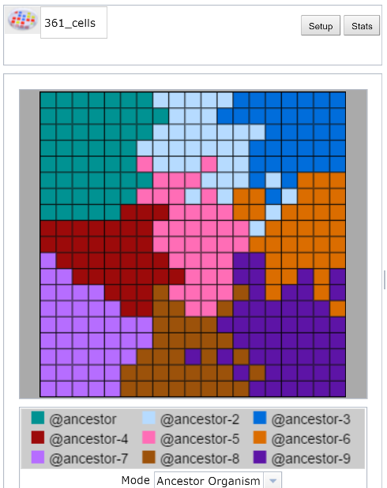
This experiment began with nine Avidian ancestors of identical fitness; the mutation rate is zero percent. Since descendants can never differ in fitness, will evolution occur in this population?

Student Learning Goals
- Students will be able to explain how non-adaptive evolutionary change can occur.
- Students will be able to explain the relationship between population size and genetic drift, and the relationship between population diversity and genetic drift.

Questions to Consider as You Go Through Exercise #4
- Is natural selection the only process that produces evolutionary change?
- What does “random sampling” mean in this biological context?
- What does population size have to do with genetic drift?
- How does genetic drift affect diversity in a population?

Evolution occurs whenever there are differences between individuals in contributing to future generations. If those differences are due to an organism’s ability to reproduce then adaptive evolution or natural selection occurs. If those differences are due to a random sampling process then neutral evolution or genetic drift occurs. In this exercise we will observe that the process of genetic drift leads to population change, and that its effect of decreasing population diversity is more pronounced in populations with fewer individuals.

Genetic Drift
Genetic drift is the change in genetic frequencies within a population due to random sampling. Sampling effects entail both A) random differences in drawing genotypes during reproduction, and B) chance variation in the survival and/or reproduction of individuals. This occurs in Avida-ED when multiple Avidians reproduce on the same update, since their offspring will be randomly chosen for placement onto a random grid location on the Map, with each location only able to contain one organism. This offspring placement can result in A) one offspring precluding the existence of another when instantly placed at the same location, and B) an offspring overwriting (“killing”) an aging Avidian, therefore preventing it from completing its reproduction. Note that these random sampling effects occur differently for other organisms, especially sexual diploid species, but have identical consequences.

Both the processes of natural selection and genetic drift affect changes in genetic frequencies within evolving populations. Random change due to sampling effects occurs whenever a population is finite in size, so genetic drift will always affect evolving populations. But not all populations experience these effects to the same extent. Smaller populations will be more greatly affected by genetic drift, and larger populations less so. Natural selection occurs whenever organisms in a population vary in fitness, which nearly always occurs because organisms tend to vary from one another due to mutations, some of which affect fitness. Selection can vary in strength because some mutations have large effects and others only minor. The influence of each process in an evolving population is neither equal nor all-or-nothing; both genetic drift and natural selection always act, though the relative influence of each is affected by population size and the strength of selection.

In this exercise you will investigate the effects of genetic drift alone by ensuring that adaptive evolution cannot occur. Since natural selection requires phenotypically expressed genotypic variation, we must eliminate the source of this variation by setting the mutation rate to 0%. Your experiments will begin with nine cloned Avidian ancestor types. In order to visualize genetic drift in Avida-ED, your experiments will use these nine identical ancestors whose descendants we can easily track over the course of evolution by using the “Ancestor Organism” map mode. Note that a more realistic experiment would use distinct genotypes that have identical fitness, since evolution is the change in genetic frequencies in a population – the idea here is the same. You will visualize and record the number of descendant types, or familial lineages, remaining in the population after 300 updates. By observing changes in descendant type diversity over multiple experimental replicates and population sizes, you will investigate the relationship between population size and the influence of genetic drift.

Before you begin collecting data:
- Do you expect the diversity of descendant types (number of colors) to stay the same, increase, or decrease over the course of each experimental replicate? Why?

- For a given population size, do you expect each experimental replicate to have the same result? If so, how? If not, how might they differ?

- Do you expect population size (larger versus smaller) will influence the evolutionary dynamics? If so, how might the results differ? If not, how could the experimental protocol be modified to better investigate this factor?

Visualizing evolutionary change without natural selection

- In the Population viewer, flip to Setup.
- Drag “@ancestor” from the Freezer to the Ancestral Organism(s) box nine times, resulting in organisms “@ancestor” through “@ancestor-9”; order does not matter. If you fail to place all nine organisms then you might receive an error message!
- Set the following parameters:
0% Per Site Mutation Rate; Place Offspring Near their parent; Uncheck all resources; Repeatability Mode Experimental; Pause Run At update 300.
- For the first series of replicates, set the Dish Size to 3x3 (total of 9 cells). In the Freezer menu choose “Save Experiment Configuration,” and enter the name “9_cells” to save this setup.
- Return to Map view. Below the Map, set Mode to “Ancestor Organism” (see bottom of image at beginning of this exercise). Each ancestor will be uniquely colored and this “descendant type” will visually denote each ancestor’s descendants.
- Select Run, and the experiment should pause automatically at update 300.
Note: if fixation occurs – when all cells become an identical color – there’s no need to continue the full 300 updates because no new variation can occur.
- Record in Table 1 the number of remaining descendant types (colors).
- In the Control menu choose “Start New Experiment” and then “Discard.” Drag “9_cells” from the Freezer’s Configured Dishes section to the small box next to the Avida symbol above the Map (see top left of image at beginning of this exercise). Visually confirm your experiment looks correct in the Setup and Map views.

- Repeat steps 6-9 for all five replicates of population size 9 (Dish Size 3x3). Once completed, calculate the average final diversity.

- Repeat steps 1-10 for population size 81 (Dish Size 9x9). Save your experimental configuration (“81_cells”) for use with each replicate. Note: Figure 1 requires an approximation of your observations regarding descendant type “@ancestor-3.” Do not record precise data; instead, sketch your observations for each replicate, resulting in five lines on the graph. After each replicate, record the pattern of relative descendant type abundance that you observed. For example, if near the beginning of the run the number of “@ancestor-3” colored descendants increased compared to each of the other differently colored organisms, then the relative frequency has increased. Do the same throughout the course of each run.
In Google Docs select the entire figure, copy it, while still selected go to “Insert” then ”Drawing”, paste it, use line or scribble marks for your predictions, select “Save & Close.”

- Repeat steps 1-10 for population size 361 (Dish Size 19x19). Again, save your experimental configuration (“361_cells”) for use with each replicate.

Table 1. Diversity of descendant types (number of colors) across experimental replicates for various population sizes.
 | Final descendant type diversity by population size (dish configuration)
Replicate | 9 (3x3) | 81 (9x9) | 361 (19x19)
1
2
3
4
5
Average

For Figure 1, do not record exact data – jot the approximate patterns you witnessed over the course of observing five replicates (one line per replicate). Note “@ancestor-3” is merely a specific variant. Percentages of note: Initial = one of nine ancestors = 11%; Extinction = 0%; Fixation = 100%.

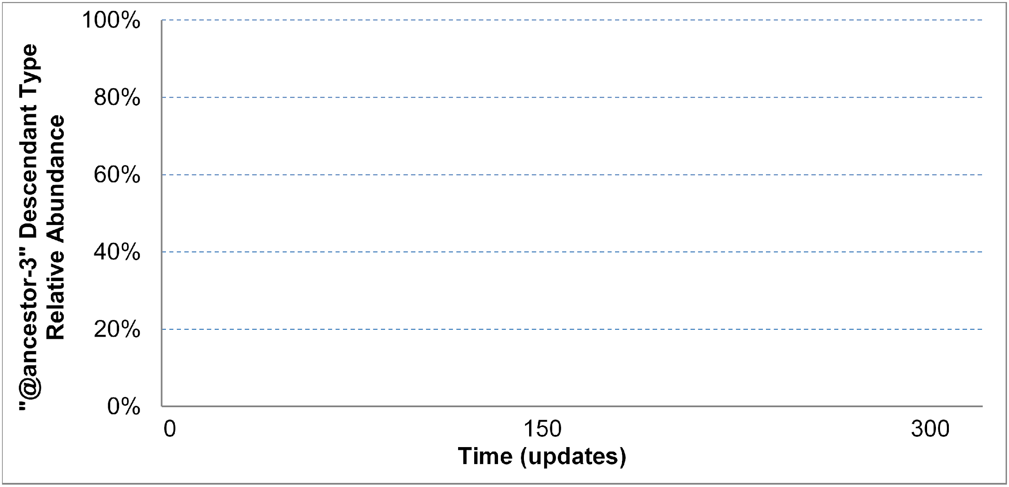
Figure 1. Approximate relative abundance of “@ancestor-3” descendant type in an evolving population of at most 81 organisms across five replicates.

Recording your data. Since experiments in biology often involve investigating processes or phenomena with lots of variation, we will be examining the data generated by all semesters’ students. Enter your transposed final row of Table 1 data, the average final descendant type diversity in each experimental treatment, here: https://docs.google.com/spreadsheets/d/1QRXp0AcEDd0K6b3a2qavtv1j1Mscp1IJwuS1HDxoa48/edit?usp=sharing

Follow the “Example” in column B. Find the first column on the right that does not contain data; enter your name in row 3, and your transposed final row of Table 1 data on the following rows, matching the column of your Table 1 to the corresponding experimental treatment row on the course data sheet. The instructors will periodically collect this data, anonymize it, and add it to the course data set.

Once you have entered your data, compared and discussed your group’s data, and completed all responses and data entry except the Discussion Questions on the next page, then you are ready to view the data. A link to view the data will be displayed
with the confirmation message once you indicate your readiness here: https://goo.gl/forms/ibKt0SPeCCYSFR8w1

Discussion Questions and Wrap-up. After examining the course data, work with your lab team to respond to the following questions.

- How does this experimental setup test the sole influence of genetic drift on the evolution of a population?

- Did the same descendant types (colors) go extinct for each of your runs?

- Thought experiment – How much final descendant type diversity would you expect to find if you ran your replicates of population size 361 for 10,000 more updates (i.e., a much longer time)?

- What impact does genetic drift have on diversity in an evolving population?

- How does population size influence the effects of genetic drift?

- Thought experiment – How would Figure 1 be different for a population of smaller size (for example, 5 organisms)? And for a much larger population size?

- Have you seen the effects of genetic drift in any previous Avida-ED experiment(s)? If so, describe what occurred and why you think genetic drift was a cause. If not, why don’t you think so?

- Why does genetic drift always occur in an evolving population?

- We used Avida-ED and this experimental protocol to model what occurs when biological populations experience genetic drift. What are some limitations or constraints to our modeling in this exercise?

Reflection and Metacognition
Think-Pair-Share: Work with your lab team to answer the following questions.

- What did you learn from this exercise?

- What are you still wondering about?

- What would you change in this exercise?

