An Investigation of Island Biogeography using
Data from Online Natural History Collections

Learning Objectives

Students will be able to:
- Analyze and explain patterns of species distribution on islands compared to the mainland.
- Analyze and explain morphological characteristics of species on islands compared to the mainland.
- Interpret patterns of species distribution and/or species’ characteristics using natural history collections data.
- Apply the process of science by the development and testing of hypotheses.
- Use quantitative reasoning to collect, clean, and analyze data from a large, curated, aggregated dataset.

Supplementary Resources

- Biology Textbook, such as “Freeman, et al. Biological Science. 6th edition, Scott Freeman, Prentice Hall, 2010.”

- http://www.pbs.org/wgbh/nova/evolution/gigantism-and-dwarfism-islands.html

Note to instructors: These instructions assume that students have already learned how to run a regression analysis and t-test and to use excel. If this module is being used to introduce any of these skills, additional instructions will be required.

Acknowledgements: Libby Beckman and Yadeeh Sawyer initiated this module. Others that have contributed to it include Kayce Bell and Joseph Cook.
See www.aimup.unm.edu .

Island Biogeography

Island biogeography is the study of the distribution and dynamics of insular (island) species. Island systems are natural laboratories for evolutionary processes, due to their natural fragmentation and variation in available area. Island biogeography can also provide a foundation for the design of conservation plans. Over the past 150 years, studies of islands systems played a fundamental role in the formation of ecological and evolutionary theory, including advances in our understanding of processes related to colonization, extinction, and speciation. Today, new technology (e.g., DNA markers, GoogleEarth, GIS applications) allows intensive studies of island systems worldwide and these studies are providing new insights into these important biomes. Studies of island systems are especially important for conservation efforts because islands harbor a very large number of endemic species and many are endangered (or already extinct). For all terrestrial vertebrates, more than 50% of all documented extinctions in the past 400 years have been island species.

It is important to think about the history of each island. Islands can be classified as either oceanic or continental by assessing their geological origin. Oceanic islands are formed over oceanic plates and were never connected to continental landmasses. These islands typically are devoid of life at the outset but gradually accumulate species from distant mainland source populations. In contrast, continental (land bridge) islands are found on the continental shelf and in the past were directly connected to the mainland, often during the Pleistocene ice advances when sea level dropped as much as 130 m. Because of their proximity to the mainland, land bridge islands are more heavily dominated by repeated colonization than are distant island archipelagoes. Repeated colonization can result in a relatively high diversity of lineages. Some organisms also have diversified on islands, with new species arising that remain endemic to only that area on earth.

Observation and analysis of species distributions and morphological adaptations on islands has led to the discovery of several evolutionary patterns. Many of these observations were formalized into “rules”. For example Rapoport’s Rule postulates that species at lower latitudes occupy smaller ranges than those at higher latitudes. Gloger’s Rule that states that within a species, darker pigmentation occurs in more humid environments and lighter coloration in drier areas. Other key island biogeography patterns include:
- Species Richness (MacArthur and Wilson, 1963): Compared to the mainland, all islands should have lower species diversity. Small islands should have lower species diversity than larger islands.
- Island Rule (Foster 1964): The optimal mammal body size is 100g. For mammals smaller than 100g, compared to the mainland, within a species, organisms will become larger. For mammals larger than 100g, compared to the mainland, within a species, organisms will become smaller.

We will be testing these last two ideas during this module.

The Alexander Archipelago (AA)

The study area for this module is the Alexander Archipelago (AA) of Southeast Alaska. The archipelago contains about 1,100 named islands. The AA is part of both the largest temperate rainforest in the world, and the largest National Forest in the United States, the Tongass. This moldule will focus on 47 of the 1,100 named islands. The 47 islands were chosen based on specimen availability in Arctos as well as the focal islands in Mammals and Amphibians of Southeast Alaska (MacDonald and Cook 2006). This particular island system also provides the opportunity to address issues relating to latitudinal variation, as it is a high latitude archipelago. The observed patterns may reflect those observed for both oceanic and continental islands. The AA is a continental island, with varying degrees of isolation and connectivity, as a result of historical climate change and complex glacial history. The glacial history may result in the islands acting as oceanic islands, and the ice receded from the area, providing “new” opportunities for colonization.

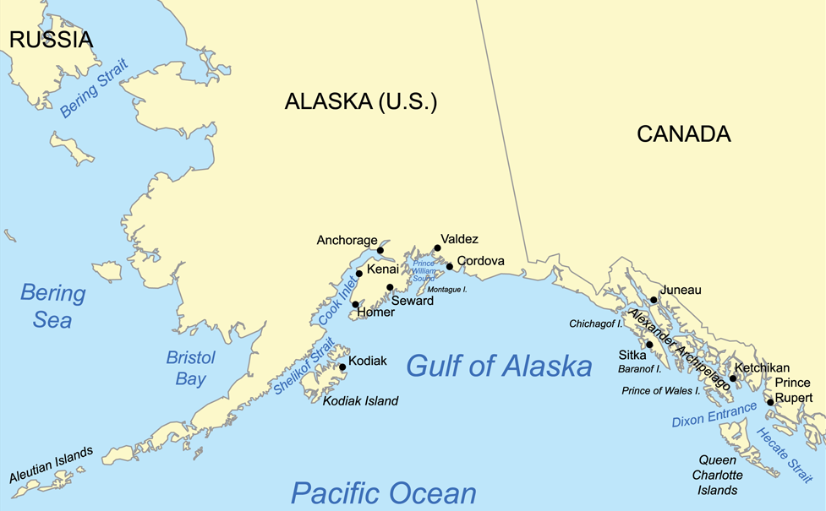

Activity

Develop a Testable Hypothesis

- Obtain the excel sheet from the laboratory instructor with the list of islands that have samples on Arctos and their associated areas. There should be a total of 47 listed islands. Each island also has a size group associated with it. This will be used when choosing which islands to include in your data collection and analysis.

- Choose one of the two questions (or your instructor will assign them)
  - Species Richness: Total # of species across the islands for 2 islands from each island group and the mainland (4 groups total).
  - Island Rule: Select a species (or your instructor will assign one) from the list of potential species (found in the Excel file with island area), to assess differences in body size as related to island area, for 2 islands per island size and mainland (4 groups total).

- Based off your background reading, formulate a hypothesis predicting the way species diversity or body size in mammals will relate to island area. Give a brief justification of your hypothesis.

- Discuss what you would have to do to test this hypothesis.

Species Richness Data Collection

- Choose 2 islands in each island size group (1, 2, 3, 4)

- Go to the Arctos database (http://arctos.database.museum/SpecimenSearch.cfm) and log in (create a user ID if you do not already have one)
  - For “Collection” select “check all”
  - For “Locality” click on “show more options”. Under Island Group select “Alexander Archipelago”. For “Island”, enter one of your island names
  - Select “Search”
Note: When the data table is displayed, make sure the island name, the state, phylclass, and the species’ names are included in this display. You may need to “customize” the results. If so, select the drop down menu labeled “Tools: Map, Customize, or Download” and choose “Add or Remove Data Fields (columns)” and select the data columns you wish to add or remove.
Note: It is much easier to clean up your data in excel, so don’t worry about removing any unwanted rows before downloading.

- From the Tools menu, select “Download”. Choose “educational” as the purpose of the download and read and agree to the terms of use statement. Then select “Continue to Download”.

- Rename your downloaded data file with the name of the Island.

- Repeat steps 2-4 for each island (for a total of eight islands).

- Repeat steps 2-4 for the mainland:
  - In Arctos, under Locality, choose “Select on Google maps”. Click on “Click to open spatial query tool” and use the selection box to highlight the region that includes the Alexander Archipelago (see map on handout) and part of the nearby mainland. Enter “Alaska” in the State field. Select “Search”.
Note: The selection tool does not work on Safari web browser.
  - After exporting your data into excel, select all, sort by “Island” and remove all island data, leaving only the mainland data.

- To create a list of which species are found on each island:
  - Open each spreadsheet individually. Select all of your data. Sort by Island and State_Province. Delete any rows that are not from your island in Alaska.
  - Sort by “phylclass” and remove any rows that are not mammals.
  - Under the Data tab, select “Remove Duplicates” and select the column containing the Scientific Name. Click “remove duplicates”.
  - Sort by Scientific_Name and review the results. Treat all subspecies as the same species, i.e. remove any additional subspecies or misspellings.
  - Count the total number of species for each island and the mainland and enter this data into the spreadsheet you received from your laboratory instructor.

What assumptions are you making about the data you have collected from Arctos?

Species Richness Data Analysis

- Run a regression analysis on the data (x=island size, y=#species), excluding the mainland samples.
  - Use the actual island area values, not the group numbers.
  - Review the results of the analysis to determine if the data support or reject your hypothesis.

- Create a scatter x/y graph in Excel, including a “trendline”.

- Repeat steps 9-10; this time including the mainland.

- Write up a formal lab report.

Lab Report Requirements:
- Title
- Introduction
  - Background information on island biogeography
  - Specific question, hypothesis and associated predictions
- Methods
  - Do not include a description of how to run Arctos searches
  - Do include a description of how you cleaned the data prior to analysis
- Results
  - Results of statistical analyses
  - Figures with legends
- Discussion
  - Explain your results and discuss whether they support or reject your hypothesis.
  - Must include reference to at least 2 scientific papers (1 provided, 1 found by students)
  - Must include at least one alternative hypothesis and associated predictions.
  - Mus address assumptions being made related to the predictions.

Island Rule Data Collection

- Select one large (>100g) and one small (<100g) species from this list provided by your instructor.

- Go to the Arctos database (http://arctos.database.museum/SpecimenSearch.cfm) and log in (create a user ID if you do not already have one)
  - For “Collection” select “check all”
  - For “Identification” enter your species name.
  - Under Locality, choose “Select on Google maps”. Click on “Click to open spatial query tool” and use the selection box to highlight the region that includes the entire Alexander Archipelago (see map on handout) and part of the nearby mainland.
  - Select “Search”

Note: When the data table is displayed, make sure the specific island, the state, the species’ names (“identified as”), and the weight are included in this display. You may need to “customize” the results. If so, select the drop down menu labeled “Tools: Map, Customize, or Download” and choose “Add or Remove Data Fields (columns)” and select the data columns you wish to add or remove.
Note: It is much easier to clean up your data in excel, so don’t worry about removing any unwanted rows before downloading.

- From the Tools menu, select “Download”. Choose “educational” as the purpose of the download and read and agree to the terms of use statement. Then select “Continue to Download”.

- Rename your downloaded data file with the name of the species.

- Repeat steps 2-4 for the other species.

- Sort by weight and delete any records that do not include weight information.

- Make sure that all weights are reported in grams. Make any necessary conversions.

- Sort by Island. Remove any records from islands that are not on the Alexander Archipelago Island Size list provided by your instructor.

- Check the Spec_Locality field to determine if any additional records are from islands. Make adjustments as necessary.

What assumptions are you making about the data you have collected from Arctos?

Island Rule Data Analysis

- Calculate the average body weight for each island and the mainland (records that do not have the “island” field filled in).

- To determine if island size influences mammal size, run a regression analysis on the data (x=island size, y=body weight), excluding the mainland samples, for each species.
  - Use the actual island area values, not the group numbers.
  - Review the results of the analysis to determine if the data support or reject your hypothesis.

- Create a scatter x/y graph presenting the data, including a “trendline”.

OR

- To determine if body size of mammals on islands is significantly different than on the mainland, run a t-test on the data (all island body weights vs mainland body weights) for each species.
  - Review the results of the analyses to determine if the data support or reject your hypothesis.

- Create a bar graph presenting the data.

- Write up a formal lab report.

Lab Report Requirements:
- Title
- Introduction
  - Background information on island biogeography
  - Specific question, hypothesis and associated predictions
- Methods
  - Do not include a description of how to run Arctos searches
  - Do include a description of how you cleaned the data prior to analysis
- Results
  - Results of statistical analyses
  - Figures with legends
- Discussion
  - Explain your results and discuss whether they support or reject your hypothesis.
  - Must include reference to at least 2 scientific papers (1 provided, 1 found by students)
  - Must include at least one alternative hypothesis and associated predictions.
  - Mus address assumptions being made related to the predictions.

