An Investigation of the “Island Rule”
using Data from Online
Natural History Collections

Objectives

Students completing this module will be able to:
- Analyze and explain patterns of species morphology on islands.
- Interpret patterns of species morphology using natural history collections data.
- Use quantitative reasoning to collect, clean, and analyze data from a large, curated, aggregated dataset.

Introduction

Island biogeography is the study of the distribution and dynamics of species on islands. Island systems are natural laboratories for evolutionary processes, due to their natural fragmentation and variation in available area. Over the past 150 years, studies of islands systems have played a fundamental role in the formation of ecological and evolutionary theory, including advances in our understanding of processes related to colonization, extinction, and speciation.

One such ecological principle that was discovered in the study of island biogeography is the relationship between the sizes of animals on islands compared to on the mainland. In the 1960’s, an ecologist named J. Bristol Foster noted that animals found on islands are often different in size from individuals of the same species found on the nearest mainland. He proposed that these size differences were due to differing evolutionary selection pressure on islands compared with the mainland. Foster compared island and mainland individuals from 116 species and developed “Foster’s Rule”, also called the Island Rule or Island Effect, to describe this phenomenon.

In this module, you will be using natural history collections data to compare the sizes of individuals from several mammal species found on islands in the Alexander Archipelago (Figure 1) with specimens from the same species collected from mainland Canada. The Alexander Archipelago is part of both the largest temperate rainforest in the world, and the largest National Forest in the United States, the Tongass. These islands were the focus of collection efforts for the publication of “Mammals and Amphibians of Southeast Alaska” (MacDonald and Cook 2006) and were chosen based on specimen availability in digitized natural history collections. Please note that although there was a fairly extensive and systematic sampling protocol for the MacDonald and Cook (2006) publication, the sampling protocol was not specifically designed to test Foster’s Rule. Therefore, your results should be interpreted cautiously.

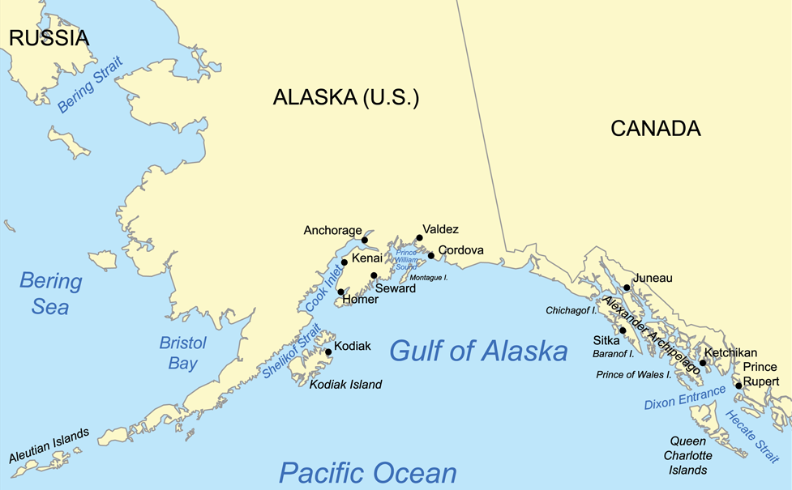
Figure 1. Location of Alexander Archipelago.

Activity 1: Develop a Testable Hypothesis

The introduction to this module does not describe the actual relationship Foster identified between the body sizes of island and mainland mammals. Before you begin collecting data, discuss the possible differences in selection pressures on islands compared with the mainland and use this information to develop a testable hypothesis about the comparison between mammal size on islands and the mainland. Consider whether you would expect the relationship to be the same for both large and small-bodied mammal species.

- Write your hypothesis below.

Activity 2: Investigate Data Resources

We will be accessing mammal size data from natural history collections. These data are based on archived specimens cared for in perpetuity to serve as a reference for the taxonomy, evolution, and ecology of the species. These voucher specimens are linked with valuable metadata (e.g., collection date, location, size, images) and are accessible for repeatable or expanded observations as physical verification is needed, new questions arise, or new investigative techniques are developed. Natural history collections provide a source of biodiversity data that is unparalleled in temporal, geographic, and taxonomic complexity.

We will be using the Arctos system. Arctos is a collection management information system that provides access to a large collection of digitized natural history museum records.

Procedure

- Go to the Arctos database (http://arctos.database.museum/SpecimenSearch.cfm) and log in (Note: You must create a free user ID if you do not already have one or you will not be able to download your data)

- For practice, search for “Ursus maritimus”, the polar bear.

- When your data are returned, make sure that the data includes a column labeled “WEIGHT”. If it doesn't, follow the instructions under #7 on the Arctos User Guide to add the column.

- Download the dataset.

- Sort your data by Scientific_Name and eliminate any rows that are not for Ursus maritimus.

- Sort by Country, and eliminate any records that aren’t in North America or don’t have a country listed.

- Sort by Weight and eliminate any rows of organisms that do not have weight data.

- Make sure that all weights are reported in kilograms. Make any necessary conversions. Eliminate units from the WEIGHT column, so excel will recognize these as numbers.

- Eliminate any obvious errors/outliers.

- Estimate the average mass of a North American polar bear by calculating a mean for the mass data column.

Note that some of the data records have the sex of the specimen recorded. A few of the records include some information about the age of the animal when the specimen was collected. How might these additional data influence your interpretation of the mass data?

Activity 3: Collect Species Size Data

Table 1 includes a list of 12 mammals found in the Alexander Archipelago that can be used in your study. The mammals have been divided into two size classes, with animals in Group 1 typically larger than 100g and animals in Group 2 smaller than 100g. Your laboratory instructor will assign you one species from each size class.

Table 1. Alexander Archipelago mammals available for study.
Mammal Size Group | Mammal Scientific Name | Mammal Common Name
1 | Canis lupus | Gray Wolf
1 | Glaucomys sabrinus | Northern Flying Squirrel
1 | Martes Americana | American Marten
1 | Mustela erminea | Short-tailed Weasel
1 | Phoca vitulina | Harbor Seal
1 | Tamisciurus hudsonicus | American Red Squirrel
2 | Microtus longicaudus | Long-tailed Vole
2 | Microtus oeconomus | Tundra Vole
2 | Microtus pennsylvanica | Meadow Vole
2 | Peromyscus keeni | Northwestern Deer Mouse
2 | Sorex cinereus | Masked Shrew
2 | Sorex monticolus | Dusky Shrew

Procedure

- Go to the Arctos database (http://arctos.database.museum/SpecimenSearch.cfm).

- For “Collection” select “check all”

- For “Identification” enter your first species name.

- Under Locality, choose “Select on Google Map”. Click on “Click to open spatial query tool” and highlight the region that includes the entire Alexander Archipelago and a large part of the nearby mainland at the same latitudes.

- Select “Search".
- Note: When the data table is displayed, make sure the specific island, the state, the species’ names (“identified as”), and the weight are included in this display. If they are not, you may need to “customize” the results. If so, select the drop-down menu labeled “Tools: Map, Customize, or Download” and choose “Add or Remove Data Fields (columns)” and select the data columns you wish to add or remove.

- From the Tools menu, select “Download”. Choose “educational” as the purpose of the download and read and agree to the terms of use statement. Then select “Continue to Download”.

- Rename your downloaded data file with the name of the species.

- Repeat steps 2-7 for the other species

Activity 4: Clean your Data

Raw data downloaded from a large database often requires “cleaning” prior to using the data for analyses. Cleaning is the process of correcting or removing inaccurate or incomplete records from a data set and/or eliminating data that is not relevant to your question.

Procedure

- Optional: For ease of use, delete any unnecessary columns. The only columns you need for this module are “Island” and “Weight”, but consider keeping the “Date”, “Sex”, and “Age” columns to provide added context for your data.

- Sort your entire spreadsheet by weight and delete any records that do not include weight information.

- Convert all weights to grams. This is the longest part and will take several steps. You will need to:
  - Separate the data in pounds from the data in grams or kilograms.
  - Remove the unit abbreviations so that excel will recognize these as numerical data.
  - Use the appropriate formulas to make the conversions to grams.
    - Multiply pounds x 453.6 to convert to grams.
    - Multiply kg x 1000 to convert to grams.

- Remove any obvious outliers…data values far outside the range of the rest of the data.

- Sort by Island.

Activity 5: Analyze your Data

- Calculate the average body weight for specimens collected from islands and from the mainland (records that do not have the “island” field filled in). Record these data in Table 2 below. Obtain the data for the other species from your classmates.

- To determine if size is significantly different for each species on the island vs. the mainland, run a t-test comparing the sizes for each species individually. Record the p-value in Table 2 below.

Table 2. Average mass of specimens for each species on island and mainland.
Size Group | Mammal Common Name | Average Mass (g) Island | Average Mass (g) Mainland | Significance
1 | Gray Wolf
1 | Northern Flying Squirrel
1 | American Marten
1 | Short-tailed Weasel
1 | Harbor Seal
1 | American Red Squirrel
2 | Long-tailed Vole
2 | Tundra Vole
2 | Meadow Vole
2 | Northwestern Deer Mouse
2 | Masked Shrew
2 | Dusky Shrew

Activity 6: Visualize your Data

- Create a bar graph for both of your species.

- Print your graphs and turn them in with your lab packet.

Activity 7: Interpret Your Data

- Based on the full class set of data, how do mammal sizes compare for island vs. mainland individuals? Does this relationship differ between size classes?

- Do these data support or reject your hypothesis? Explain your evidence.

- What additional hypotheses might you be able to test using the types of data available in digitized natural history collections?

Acknowledgements: Libby Beckman and Yadeeh Sawyer initiated this module as part of the AIM-UP project (www.aimup.unm.edu). Others that have contributed to it include Kayce Bell, Joseph Cook, and Debra Linton.

