BIO 151 | A Graphing Analysis in Ecology

During the semester, we have worked hard at interpreting graphs in various contexts. We have also worked on creating graphs using different kinds of data. This activity blends the two by analyzing a figure that was published in a scientific journal. The figure is difficult to interpret, so I will present various pieces of information to you to help you interpret the figure. Figures should be able to “stand alone” meaning that the labels and figure legend are clear enough that you can easily draw conclusions from the figure. After you understand the information being presented, you will work on creating your own representation of the data.

The article the figure is taken from can be found here (https://elifesciences.org/articles/22089).

Activity 1:

- Working with your group, interpret the graph below. What are some things you know about this graph?

- Working with your group, identify what you don’t know or is missing in this graph. You will be recreating this graph at a later time, so identify everything that you don’t understand.

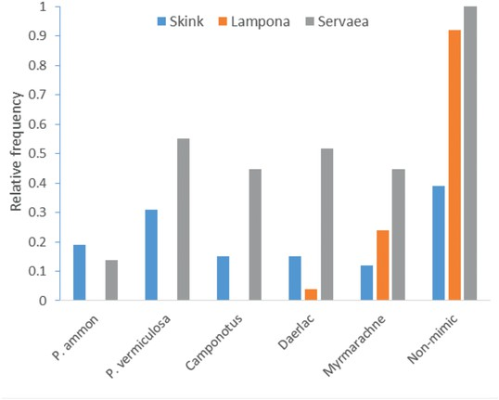
Activity 2: Below is the same graph, but with the figure legend attached from the article. Write down all the ideas that you and your group have about the various components.

- The graph you see below is the same graph, but the figure legend that is in the paper has been included. Given this information, what do you know about the graph?

- Given what you know about the graph from the figure legend, what parts of the graph are still unclear? What is missing that could make it easier to understand this graph?

Figure 6: Comparison of frequency of attacks on five mimics and one non-mimic by skinks (euryphagous visually-oriented predator); Lampona spiders (ant-adverse non-visually oriented predators), and Servaea spiders (specialised ant-eating predators).

Activity 3: The information below is an excerpt from the Results section of the paper that is directly related to the graph. There are different figures mentioned, but the graph you have been analyzing is Figure 6. Also included is a table with information that may help in understanding the graph. Read the following information carefully, highlight and mark it as you need to, then answer the follow-up questions.

“We exposed five species of mimics (ants, spiders and bugs) of varying unpalatability (Table 3) and one non-mimic (spider) to one representative of each of three guilds of naïve predator species (euryphagous skink, ant-adverse spider, ant specialist spider). Eastern water skinks (N = 26) are visually-oriented generalist predators and captured (i.e. ate) non-mimetic spiders at significantly higher frequency than members of the mimetic complex such as ants, spiders and bugs (GEE-b, X²₅ = 125.8, p<0.0001, Figure 6). We found similar patterns in the non-visually oriented ant-adverse Lampona spiders (N = 25), which captured non-mimic spiders significantly more frequently than all mimics (Cochran test, X²₅ = 104, p<0.0001, Figure 6), showing no differentiation between the mimics.

By contrast, the visually oriented ant-eating specialist Servaea spiders (N = 27) readily attacked and captured mimics as well as non-mimics. Although these spiders readily attacked the mimics they did appear to differentiate between their levels of defence (attack: GEE-b, X²₄ = 15763, p<0.0001, Figure 6). The most unpalatable ant was attacked at a significantly lower frequency than other mimics (contrasts, p<0.008) and moderately unpalatable ant species were captured at a significantly lower frequency than bug and spider mimics (contrasts, p<0.006). In summary, euryphagous and ant-adverse predators were less likely to capture a mimic than a non-mimic while the ant-specialist attacked the ants and ant-mimics alike but the likelihood of attack varied according to the mimic’s actual unpalatability.”

Table 3: A list of traits used to assess the unpalatability of five mimics. Values are means (±SE) estimated from 10 measurements. The species are arranged from the least to the most palatable.
Species | Frequency of biting | Spray chemicals | Number of spines | Total spines length [mm] | Cuticle thickness [mm] | Total body size [mm] | Mandible size [mm] | Gland size [mm²]
P. ammon | 0.1 | 1 | 4 | 3.54 (0.08) | 0.04 (0.002) | 9.04 (0.08) | 1.00 (0.02) | 2.84 (0.16)
P. vermiculosa | 0 | 1 | 6 | 2.96 (0.08) | 0.03 (0.002) | 5.98 (0.05) | 0.71 (0.03) | 1.62 (0.06)
C. aeneopilosus | 0.3 | 1 | 0 | 0 | 0.02 (0.001) | 8.04 (0.17) | 0.84 (0.02) | 2.43 (0.09)
D. nigricans | 0 | 0 | 0 | 0 | 0.02 (0.0002) | 7.40 (0.14) | 0 | 0.57 (0.03)
M. luctuosa | 0 | 0 | 0 | 0 | 0.02 (0.001) | 7.04 (0.28) | 0 | 0

- In the graph, the bars are labeled as “Servaea, Lampona, Skink” – given all of this information. What are those?

- On the x-axis of the graph, there are many different names listed. What are these? They all have different formats of names, how can you make these more unified?

- Given the information in the results, why were the names on the x-axis ordered the way they were on the graph? This is important information, how can you convey this on the graph?

Activity 4: We will be making a graph of this data in the next activity. The authors do not provide the data with the paper (which is typical), so you will need to make an estimate on the value of each variable. Use the table below as a guide. I have filled in the first row of my estimates as an example. You will set up the data in Microsoft Excel in the same orientation.

Species | Skink | Lampona | Servaea
P. ammon | 0.19 | 0 | 0.14
P. vermiculosa
Camponotus
Daerlac
Myrmarachne
Non-mimic

Activity 5: Use the ideas from your group as well as your own to make a graph of the data. The graph will still be a bar graph and look similar to the original graph with the same number and size of bars, but you can (and should) change everything else, such as axis labels, column labels, colors, etc. You will also need to write a new figure legend for your graph.

The graph and figure legend should be able to stand alone, meaning you shouldn’t have to read numerous paragraphs and look at data tables to understand what is happening. Imagine what information would have been helpful when interpreting this graph as compared to the old graph (Activities 1 & 2). The graph should also be scientific and publishable. Scientific graphs are purely black and white, extra lines are deleted, and everything looks crisp.

Checklist:
- All text and lines are black
- Bars are black, white, grayscale
- There is no legend (information is in Figure Legend)
- Font sizes are consistent
- No guidelines through graph
- Axis labels
- No title

Assignment: Complete your graph in Microsoft Excel. Then answer the following questions and submit to Blackboard:

- There were many things wrong with this graph, which do you think was the most important thing that was missing that made it hard to interpret?

- Given the information from the graph and the results, what is your conclusion about each of the predators? Do not simply restate the results. Put your conclusion in your words.

- What is mimicry? What is palatability? How do these relate to your conclusions above?

