Freezer Full of Fossils v.2
Louise S. Mead¹, Michael Wiser¹, Noah Ribeck²,
Fred Hingst³, Richard Schultz⁴, and Richard Lenski¹

The Experimental Question(s):
- What types of models describe the evolutionary trajectory of evolving populations?
- Do populations reach a maximum fitness or do populations continue to evolve even in a constant environment?

Overview of the Experimental Background
Evolutionary biologists study the dynamics of the adaptation of organisms to their environment and the divergence of populations and species from each other. But it can be very difficult to observe evolutionary change in populations because it often happens over long periods of time. It is often impossible to separate the effects of natural selection, random events, and constraints created by history. By contrast, ecologists tend to study processes that occur over much shorter time periods; ecologists often examine the immediate biotic interactions among organisms and their environments. One could say that evolution is simply the interaction of ecology and genetics over multiple generations. Births, deaths, and competition are a few of the basic processes that create the opportunity for which selection can operate as the result of mutation (random changes in the genome) and inheritance, both of which are influenced by previous history (Lenski 2017). In 1988 Dr. Richard Lenski started an evolution experiment that is still running today. On February 24, 1988 12 populations of E. coli were placed in identical environments. Each population was founded by a single cell from an asexual clone, so there was initially no genetic variation either within or between the replicate populations. The experimental environment consisted of a serial transfer regime in which populations were diluted each day into 10 ml of a glucose-limited minimal salts solution that supports ~ 5x10⁷ cells per ml. Populations were maintained at 37º C, and aeration provided oxygen and other gas exchange. Every day the bacteria population grew in size as multiple generations of E. coli cells reproduced generation after generation. This population growth consisted of various phases: a lag phase of slow growth, a period of sustained rapid growth that eventually resulted in the near-complete depletion of the glucose food source, and finally starvation until the next serial transfer. The 1:100 dilution allows the population to undergo on average ~ 6.6 generations of growth per day. Every few days, samples from each population were stored at -80ºC in a laboratory freezer; a population of the common ancestor clone was also frozen at the very start of the experiment.

A remarkable feature of this experimental system is that the mean fitness of a derived population can be measured relative to a clone of its ancestor. Whenever the scientists wish, populations of cells can be thawed from the freezer and placed into direct competition with their descendants that have been evolving for many generations. This is like resurrecting the fossils of ancient relatives and competing them with their living descendants. This allows scientists to measure evolutionary fitness as the relative increase in reproductive rate of the descendant compared to its ancestor. This ability to measure fitness allows scientists to address a number of intriguing questions. Does the E. coli population change and if so how? Has mean fitness improved over the many generations of the experiment, thus demonstrating adaptation by natural selection? Is the evolutionary trajectory for fitness similar to that observed for other trait changes (for example, changes in cell size over time)? Do populations reach an adaptive peak or maximum and no longer evolve, or do populations continue to show an increase in fitness over long periods of time? How repeatable is evolution? What are the relative roles of chance, phylogeny, and adaptation in evolution?

The following exercises allow you to interact directly with the data collected since 1988 by Dr. Richard Lenski and his colleagues, and the ability to address some of these questions yourself.

Data Sets
The datasets you will need for this exercise can be found on D2L.

Instructions
Exercise 1. Interpreting the first 300 days
After the first 300 days of the experiment, the populations of bacteria had experienced about 2,000 generations. Scientists examined a fundamental aspect of these bacteria, the fitness of a derived population to that of its ancestor. They examined this in the same environment in which the derived populations were propagated, and they did this for all 12 populations. “Metaphorically speaking, the experiment reported here consists of starting replicate populations at the exact same point in genotypic and ecological ‘space’ and then tracking their subsequent adaptation and divergence by following the mean and variance of the height of their trajectories along the adaptive surface” (Lenski et al. 1991). Simply speaking, in this experiment multiple populations that started out genetically identical were allowed to grow in an identical environment, and the fitness of the derived populations were measured relative to that of their ancestor so that the researchers could follow their adaptation and divergence by using calculated means and variances for this relative fitness measure over time. Figure 1 (from Lenski et al 1991) shows the trajectory of mean fitness over 2,000 generations (300 researcher days). Mean fitness was measured for each of the evolving populations every 100 generations.
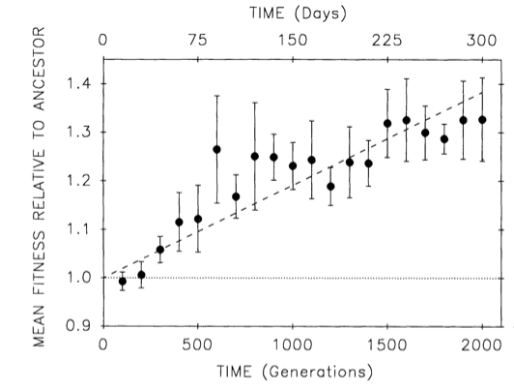
Figure 1. Average (mean) fitness over 2,000 generations. Fitness is measured relative to the ancestor. Mean fitness was estimated for each of the 12 evolving populations at 100-generation intervals. Filled circles show grand means of 12 estimates of mean fitness; a grand mean is an average across all populations at a single time point. The error bars show the 95% confidence interval based on the t- distribution with 11 degrees of freedom. The dashed line shows an estimate of the linear relationship (least squares linear regression with the intercept at 1.0) between time and mean relative fitness. (Figure adapted from Lenski et al. 1991)
Questions:
- What observations can you make from Figure 1?

- Why is the mean fitness 1.0 at the intercept, meaning when time = 0 generations?

- What does the graph represent biologically?

- What type of mathematical relationship or model do you think best describes the observed changes in fitness? Refer to specific elements of Figure 1 to support your claim.

Understanding how mutations occur and respond to selection, the scientists suspected that the data on increasing fitness might be better represented by a stepwise mathematical model (Lenski et al. 1991). Box 1 provides the mathematical explanations for these a priori expectations. The scientists examined the hypothesis of whether a step model or linear model best fit the data collected. These analyses are shown in Figure 2 for one of the populations. In all 12 populations, the step model provided a better explanation of the data.

- What do you conclude from these findings? Be specific and provide evidence to support your claim.

Box 1: According to Lenski et al (1991) there are initial theoretical reasons for doubting the strict applicability of a linear mode to the evolution of mean fitness in clonal populations. Consider the mutation (initial appearance) and fixation (subsequent complete population change) of a single advantageous mutation in one population. When the mutation first occurs, the frequency of the genotype P(0) is equal to 1/N, where N is the population size. Even if the mutation is advantageous such that the selection coefficient is greater than 0, the advantageous mutation takes many generations to reach a frequency at which it has any appreciable effect on mean fitness, followed by a comparatively few generations during which there is a more rapid increase in mean fitness, with a plateau at a mean fitness equal to 1 + Sij (the value of the selection coefficient). Therefore our initial theoretical expectation for the evolution of mean fitness is a series of steplike increases in each population as advantageous mutations accumulate.
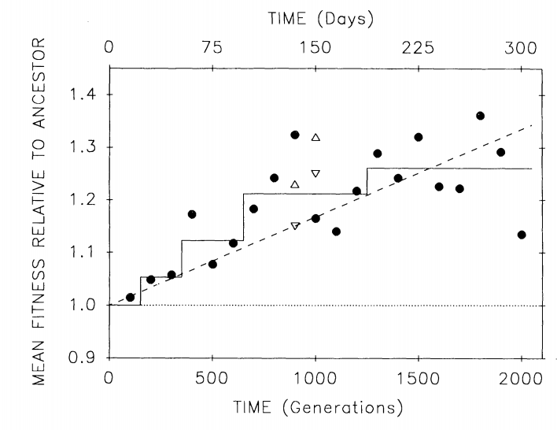
Figure 2. Average (mean) fitness for one of the 12 replicate populations. Filled circles show mean fitness. Dashed line is the least squares linear regression for the original estimates. Solid line is the fit of the step model, obtained by isotonic regression, for the estimates and with the intercept fixed at 1.0. [Adapted from Lenski et al. 1991]

Exercise 2. Evolution at 10,000 Generations
The scientists did not stop the experiment at 2,000 generations and by 1994 all 12 populations had reached 10,000 generations of evolutionary change (Lenski and Travisano 1994).
6. What is your prediction as to the expected outcome of mean fitness change over this period of time? Graph and explain your prediction.

Obtain the excel spreadsheet with the data from 10,000 generations available on D2L, LTEE 10000 Data. Create graphs of the change in fitness over generations, and graph each population separately.
7. Describe the results of your graphs, explaining specifically the evolutionary trajectory of each of the 12 different populations over the 10,000 generations.

8. What do you predict the evolutionary trajectory will be for each of the populations if Dr. Lenski continues the experiment?
Exercise 3. Evolution at 50,000 Generations
Obtain the Excel spreadsheet with the data from 50,000 generations from D2L. The average fitness for each population is provided on the first tab.
As before, graph the average relative fitness for each population separately but this time place all populations on the same graph. [Note: You can achieve this result by assigning each population to a different series on the graph each with a different indicator. PLEASE SAVE AND PRINT THIS GRAPH TO TURN IN WITH YOUR ASSIGNMENT.

9. Describe your initial observations.

10. From the additional readings for this unit, what changes in E. coli might help explain these observations (i.e. At 33,000 generations Ara-3 evolves Cit+ and maintains two types of E. coli therefore it is no longer possible to measure fitness compared to the ancestor).

If an experiment ends before 50,000 generations it means that the population could no longer be grown on a petri dish in order to carry out the fitness experiment, although the population itself has continued to evolve.
We can also describe the average changes across all populations, which is referred to as the Grand Mean.
11. Calculate the Grand Mean (average across all populations at each time point) and then calculate 95% confidence intervals. [NOTE: BE SURE TO ACCOUNT FOR THE DIFFERENT SAMPLE SIZES WHEN ESTIMATING THE MEAN AND CI].
Create a graph of the Grand Mean, with 95% confidence intervals. Please turn in this graph with the assignment.

12. Based on the data you analyzed, what do you think will happen if the experiment is continued for another 50,000 generations? [Be sure to explain the observed trend from 2000 to 10,000 to 50,000 and provide a graph for what you predict fitness will look like in another 50,000 generations].
Literature Cited:
Lenski, R. E., M. R. Rose, S. C. Simpson, and S. C. Tadler. 1991. Long-term experimental evolution in Escherichia coli. I. Adaptation and divergence during 2,000 generations. American Naturalist 138:1315-1341
Lenski, R. E., and M. Travisano. 1994. Dynamics of adaptation and diversification: a 10,000-generation experiment with bacterial populations.Proceedings of the National Academy of Sciences, USA 91:6808-6814. [Reprinted: Pp. 253-273 in F. J. Ayala and W. M. Fitch, editors. 1995. Tempo and Mode in Evolution: Genetics and Paleontology 50 Years after Simpson. National Academy Press, Washington, DC.] Lenski et al. 1991
Lenski, R. E. 2017. Experimental evolution and the dynamics of adaptation and genome evolution in microbial populations. ISME Journal, in press.

Wiser, M. J., N. Ribeck, and R. E. Lenski. 2013. Long-term dynamics of adaptation in asexual populations. Science 342:1364-1367.

1. BEACON Center for the Study of Evolution in Action, Michigan State University, East Lansing, MI.

2. University of California Santa Barbara

3. Dewitt High School, Dewitt, MI

- St. Johns High School, St. Johns, MI

Photo Source : http://myxo.css.msu.edu/ecoli/citrateflasksphotos.html

