BIO380: Cancer Biology
Homework Assignment #3: Classifying Cancer Genes
50pt, Due Wednesday Feb 1

- Watch the Cancer as a Genetic Disease video clip (https://www.hhmi.org/biointeractive/cancer-genetic-disease-video-highlights).

- Complete the worksheet handed out in class. It is also posted on moodle in case you lost it. (15pt)

- Complete the “3-2-1” analysis of the in-class activity and video: 3 things you learned, 2 things that surpised or particularly interested you and 1 question you still have. (6pt)

- Answer the following questions. (4pt)
  - Why is it important to know the loci of proto-oncogenes and tumor supressors?
  - Why might the HUGO Gene Database be a useful resource for people to know about?
  - The video discusses oncogenes being similar to a “gas pedal” and tumor supressors as a “break”. This analogy is not entirely accurate. Make up a new analogy to help others understand how oncogenes and tumor supressors work.

- Mini-research project (25pt)
Select one of the gene cards you researched and draw a concept map (example below) comparing the function of the normal gene to that of the mutated, cancer-causing gene. Suggested websites for your research include the National Institutes of Health’s (NIH’s) Genetics Home Reference website, the Online Mendelian Inheritance in Man (OMIM) online catalog, the PubMed website, and the COSMIC database.
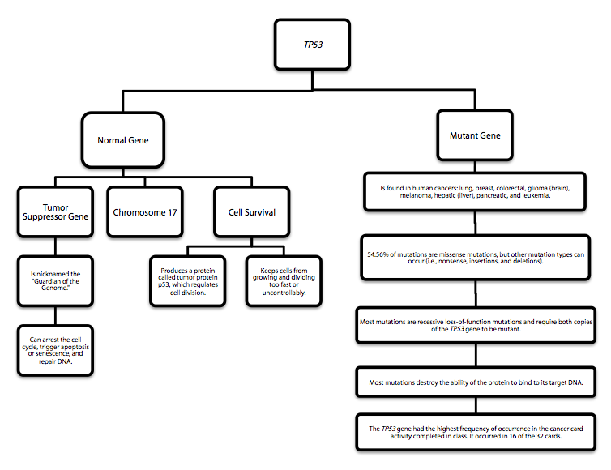

HHMI Biointeractive Website. “Cancer Discover Activities.”

