Gibb’s Free Energy and the Nature of Chemical Reactions

Introduction
In a chemical reaction, some bonds are broken in the reactants in order to form bonds in the products. Some product molecules will participate in the reverse reaction in order to reform reactants. The initial rate of product formation depends on the initial concentrations of reactants and products. As product concentration increases, the rate of the reverse reaction increases. Eventually, the rate of forward and reverse reactions become equal. Under these circumstances, the concentrations of reactants and products are constant, and the mixture is said to be in chemical equilibrium. Since breaking bonds requires energy and forming bonds releases energy, the net energy of a chemical reaction will depend on the sum of energy absorbed and generated. Eventually, the difference in energy between the reactants and products decreases as equilibrium is achieved.

Importance
We can look at the energy of a chemical reaction to predict the net direction of a chemical reaction and understand how changes in energy are related to achieving chemical equilibrium. By quantifying the free energy of reactants and products we can estimate the direction and nature of a chemical reaction.

Questions
How can we measure the energy of a chemical reaction? How can we predict the direction of a chemical reaction? How do properties of the reactants and products affect the net result of a chemical reaction?

Variables
G | Gibb's free energy (kcal/mol)
ΔGº' | Standard free energy (kcal/mol)
H | heat energy (kcal/mol)
T | temperature (Kelvin)
S | entropy (kcal/mol K)
R | universal gas constant (1.987 cal/mol K)
c_{product}, c_{reactant} | concentration of product, reactant (M)
K_{eq} | equilibrium constant

Method
A measure of free energy, the potential energy of a reaction, can be used to predict properties of chemical reactions. In the late 1800's, J. W. Gibbs showed that free energy (G) of a system can be defined as
$$G=H-TS$$ | LaTeX Code: \[ G = H - TS \]
where H is the heat energy of the system, T is the temperature, and S is entropy. Heat energy (H) is a measure of the energy in a chemical bond: tightly bound molecules have higher heat energy. Entropy (S) is a measure of the disorder in a system. Molecules distributed randomly have high entropy (large S) while ordered molecules have low entropy (small S).
Every chemical reaction result in a change in free energy which we can measure as
$$ΔG=G_{products}-G_{reactants}=H_{products}-H_{reactants}-T\left(S_{products}-S_{reactants}\right)=ΔH-TΔS$$ | LaTeX Code: \[ \Delta G = G_{products} – G_{reactants} = H_{products} – H_{reactants} – T(S_{products} – S_{reactants}) = \Delta H – T \Delta S \]
A chemical reaction will have a $ΔH<0$ if the heat energy of the reactants is greater than the products. A reaction will have $ΔS<0$ if the reaction results in increased order and $ΔS>0$ if the reaction results in increased entropy.
The net direction of a chemical reaction will be from higher to lower energy. In other words, if the energy of the reactants is higher than the energy of the products, $G_{reactants}>G_{products}$, the reaction will occur spontaneously. In such a case,$ΔG<0$, and the free energy of the system decreases with the reaction. In the opposite case, $ΔG>0$, and energy is required for the reaction to occur.
In a mixture of reactants and products, the chemical reaction and its reverse occur until chemical equilibrium is achieved. If we begin with a large concentration of reactants, the free energy of reactants is much greater than products and the reaction proceeds. As the concentration of reactants decreases as products are formed, the difference in free energy decreases until the free energy of the products and reactants are equal. Therefore, at chemical equilibrium, $ΔG=0$.
Clearly, the free energy of a chemical reaction depends on the heat energy and entropy of the reactants and products. Free energy also depends on the concentration of reactants and products. This is because the movement of molecules from a more to less concentrated state can perform work. Reference books refer to $ΔG°'$ as the standard free energy of a reaction when temperature is 298 Kelvin, pressure is 1 atm, pH is 7.0, and initial concentrations of reactants and products are equal. Some examples are given in the following table.
 | Chemical Reaction | $ΔG°'$ (kcal/mol)
photosynthesis | 6CO2 + 6H2O --> glucose + 6O2 | +686
hydrolysis of sucrose | Sucrose + H2O --> glucose + fructose | -7.0
conversion of ATP to ADP | ATP + H2O --> ADP + phosphate | -7.3
esterification | glucose + phosphate --> glucose 6-phosphate + H2O | +3.3
When the concentrations of reactants and products are variable, we can determine $ΔG$ as
$$ΔG = ΔG°'+ R ×T ×\ln{\frac{C_{product}}{C_{reactant}}}$$ | LaTeX Code: \[ \Delta G = \Delta G^{\circ \prime} + R \times T \times \ln \frac{C_{product}}{C_{reactant}} \]
where $R$ is the universal gas constant, $T$ is temperature, and $C_{product}$, $C_{reactant}$ are the initial concentrations of the products and reactants.
We can plot $ΔG$ as a function of ${C_{product}}/{C_{reactant}}$ to see how the free energy of the reaction changes as reactants are converted to product (${C_{product}}/{C_{reactant}}$ increases). As an example, we will look at chemical reaction of photosynthesiswhich has a standard free energy $ΔG°^{'}=+686 kcal/mol$. The reverse reaction has$ΔG°^{'}=-686 kcal/mol$.
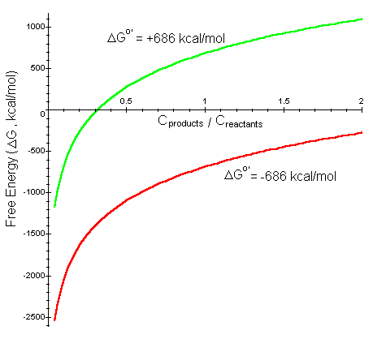

Interpretation
When the concentration of the reactants is much greater than the products (${C_{product}}/{C_{reactant}}$ much less than 1), for both photosynthesis and the reverse reaction,$ΔG$ is negative so the reaction progresses spontaneously. For the reverse reaction, as the concentration of product increases, the reaction approaches a chemical equilibrium where $ΔG=0$. For photosynthesis, however, as the amount of product increases,$ΔG$ quickly becomes positive even though less than half of the reactants have been converted to product (${C_{product}}/{C_{reactant}}<0.5$). In other words, for more product to be created, this reaction is not spontaneous, and energy is required for the chemical reaction to occur.
We can also use this equation for $ΔG$ as a function of product and reactant concentrations to determine the equilibrium constant of a reaction. The equilibrium constant ($K_{eq}$) is ${C_{product}}/{C_{reactant}}$ when chemical equilibrium is achieved ($ΔG=0$). By setting $ΔG=0$ and solving for $K_{eq}$ we find
$$K_{eq}=e^{{-ΔG°'}/{RT}}$$ | LaTeX Code: \[ K_{eq} = e^{-\Delta G^{\circ \prime} \Big/ RT} \]
We can plot $K_{eq}$ as a function of $ΔG°'$, we can see how the equilibrium constant is affected by the standard free energy of a chemical reaction.
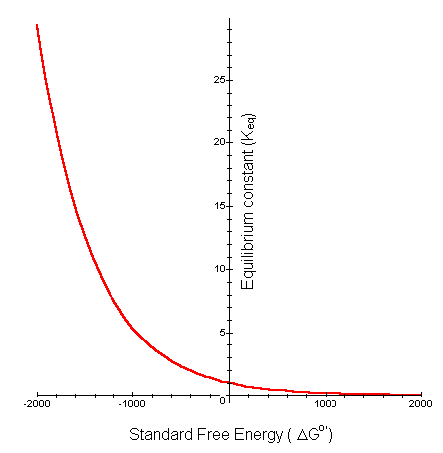
For chemical reactions where the free energy of the reactants is much greater than the free energy of the products ($ΔG°^{'}<0$), the reaction proceeds spontaneously, and the net result is a large ratio of product to reactant (large $K_{eq}$). For reactions where$ΔG°^{'}>0$, very little of the reactant may be converted to product without the input of additional energy into the system.

Conclusion
The rate and direction of a chemical reaction depends on the free energy, entropy, and concentration of the reactants and products as well as the temperature and pH of the system. Chemical reactions progress in the direction of high to low energy. We can estimate the direction of the chemical reaction, as well as the equilibrium concentrations of reactant and product, by examining the energy of the reactants and products.

Additional Questions
1. What kind of function is $ΔG$ as a function of $ΔH$? What would $-TΔS$ give us? What direction does the function shift if the entropy of the chemical reaction increases from reactants to products ($ΔS$ increases)? What change does this result in for $ΔG$?
2. Look at the equation for the change in free energy with a chemical reaction ($ΔG$). Under what conditions for $ΔH$, $T$, and $ΔS$ would you expect a spontaneous reaction ($ΔG<0$)? For example, if $ΔH>0$, is it still possible for the reaction to be spontaneous?
3. Verify that $ΔG=ΔG°^{'}$ when the initial concentrations of reactants and products are equal.
4. Verify the equation for $K_{eq}$ as a function of $ΔG°^{'}$.
5. Look at the table of standard free energies for different chemical reactions. Assuming $T=298$ Kelvin, calculate the equilibrium constant ($K_{eq}$) for each reaction. Which of these reactions would occur spontaneously?

Source
Darnell, J., H. Lodish, and D. Baltimore. 1986. Molecular Cell Biology. Scientific American Books, Inc., New York
Tobin, A. J. and R. E. Morel. 1997. Asking About Cells. Harcourt Brace & Company, New York.

About this Resource
This material was originally distributed as part of “Alternative Routes to Quantitative Literacy for the Life Sciences” - National Science Foundation Award DUE-9752339 to the University of Tennessee, Knoxville for August 1, 1998 - July 31, 2000. Principal Investigator: Louis J. Gross. Co-Principal Investigators: Beth C. Mullin and Susan E. Riechert.
This material is now being revised as part of the “Resources for Improving Quantitative Skills in Community College Biology” project. As part of that project is also aligned with the OpenStax Biology Textbook.
It is published using the QUBES Open Education Resources publishing platform.

http://www.tiem.utk.edu/~gross/bioed/
https://qubeshub.org/community/groups/quantbioatcc/
https://openstax.org/details/books/biology-2e
https://qubeshub.org/qubesresources/publications/969/

